热缩原理：

利用高分子聚合物“弹性记忆”原理，以橡塑材料为基料，经配方设计和混炼造粒，然后采用挤出、模压或注射成型，再经辐照交联或化学交联，最后采用真空或机械扩张，制成一系列具有不同尺寸、形状和性能的热收缩绝缘材料制品，包括模缩套、热缩管、指套等。该类热收缩绝缘材料制品具有优良的机械性能、绝缘性能、阻燃性能以及耐热、耐油、耐腐蚀、耐盐雾和使用方便可靠等特点，被广泛应用于线缆、焊点、接头和电子元器件的应力解除、机械保护、绝缘、密封和接续等领域。

Using the principle of "elastic memory" of polymer materials, a series of heat shrink insulation materials with different sizes, shapes, and properties are produced using rubber and plastic materials as the base material, through formula design and mixing granulation, followed by extrusion, molding, or injection molding, followed by irradiation crosslinking or chemical crosslinking, and finally vacuum or mechanical expansion, including mold shrink sleeves, heat shrink tubes, finger sleeves, etc. This type of heat shrink insulation material product has excellent mechanical properties, insulation properties, flame retardant properties, as well as characteristics such as heat resistance, oil resistance, corrosion resistance, salt spray resistance, and convenient and reliable use. It is widely used in stress relief, mechanical protection, insulation, sealing, and connection of cables, solder joints, joints, and electronic components.
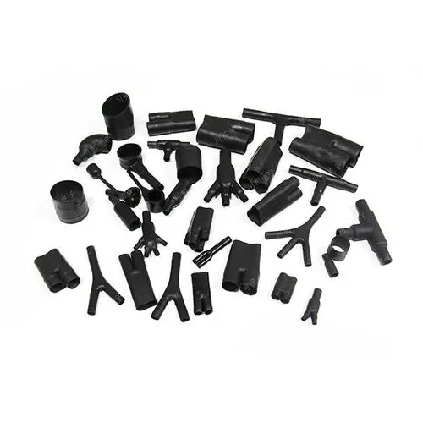

模缩套产品
Heat Shrink Molded Parts

介绍Introduction
模缩套产品由多相阻燃聚合物经交联、扩张和热处理工艺制成。可通过热风枪加热将其收缩至预膨胀尺寸。模缩套有多种形状和材料选择，广泛用于电缆插头、电缆分段的密封防潮、机械保护、电器绝缘、消除应力等领域，有助于抵御恶劣环境。
Made by multi-phase flame-retardant Polymer by cross-linking, expanding and heat treatment process. It can be retracted to the pre-expanded size by heating with hot air gun. Heat shrinkable molded parts in a range of shapes and materials are used for cable plug, cable division playing the Seal moisture-proof, the mechanical protection, the electrical appliance insulation, eliminates the stress, and so on.to help withstand harsh environments.

模缩套/过渡开口异型件/模制套管/定位衬套
----Boots/Transitions / Breakouts/ Molded sleeve/ Locating Bushes
非常适合在电缆或电线与连接器或连接器适配器之间提供高性能环境密封和机械保护。热收缩模缩套可用于电缆断开、过渡和终端，可替代传统的胶带、模制环氧树脂和润滑脂。
Ideal for providing a high performance environmental seal and mechanical protection between the cable or wire and the connector or connector adaptor. Replacement for tapes, mold-in-place epoxies and grease. Heat shrink molded parts can be used for cable breakouts, transitions and terminations.

功能和优点Features & Benefits
• 机械保护 Mechanical protection
• 耐化学性Chemical resistance
• 电绝缘 Electrical insulation
• 电屏蔽Electrical screening
• 耐液体和溶剂Fluid and solvent resistance
• 防潮Moisture protection
• 应力解除Strain relief
• 低烟阻燃Flame-retardant, low smoke
• 耐高低温Extreme temperature performance
• 外观优美Aesthetic enhancement
• 安装便捷Fast & efficient installation
• 选材广泛Wide range of materials
• 预涂热熔胶Pre-installed adhesives
• 可定制Modification options

产品编号
Part Number

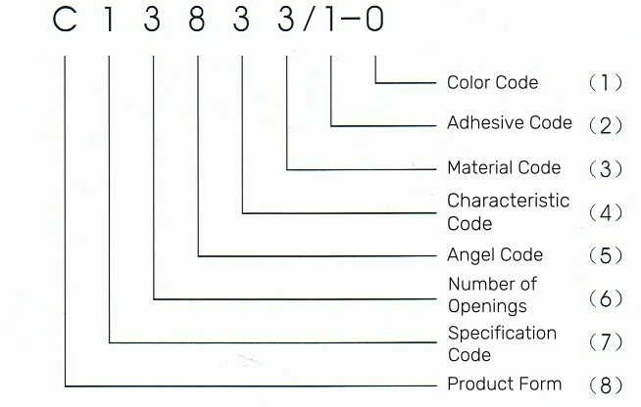

（1）颜色代码： 0—黑 1—棕 2—红 3—橙 4—黄 5—绿 6—蓝 7—紫 8—灰 9—白
Color Code: 0—black 1—brown 2—red 3—orange 4—yellow 5—green 6—blue 7—purple 8—grey 9—white
（2）预涂热熔胶代码：1—聚酰胺型 2—EVA型
Precoating hot melt adhesive code: 1—Polyamide type 2—EVA type
（3）材料代码：1—阻燃半硬聚烯烃 2—阻燃半柔软聚烯烃 3 —阻燃柔软聚烯烃 4---无卤阻燃聚烯烃
Material Code: 1—Semi-hard flame retardant polyolefin 2—Semi-soft flame retardant polyolefin 3 —Soft flame retardant polyolefin 4--- Halogen free flame retardant polyolefin
（4）特点代码：1—普通型 2—加长型 3—薄型
Characteristic Code: 1—normal type 2—elongated type 3—thin wall type
（5）角度代码：1—180° 3—30° 4—45° 9—90° 5—T形 8—Y形
Angel Code: 1—180° 3—30° 4—45° 9—90° 5—T type 8—Y type
（6）开口数：2—2个开口 3—3个开口 4—4个开口 5—5个开口
Number of Openings: 2—two openings 3—three openings 4—four openings 5—five openings
（7）规格代码：规格以相应开口内径的扩后扩前之比表示，数字越小，形体尺寸越小。
Specification Code: The smaller the number, the smaller the body size, is expressed as the ratio of the expanded inner diameter of the corresponding opening to the fully contracted inner diameter
（8）产品形态：Z—直型 W—弯型 C—叉型 T—T型
Product form: Z—straight type W—curving type C—forked type T—T type
常规情况下180°、90°、2开品、普通型的代码省略。
Typically, the code of 180°, 90°, two openings or normal type is omitted.

材料选择
Materials Available for Heat Shrink Molded Parts

材料代码  Material Code | 3 | 4 | 12 | 25 | 51 | 100
材料  Material | 阻燃半硬聚烯烃Semi-rigid flame retarded polyolefin | 阻燃柔软聚烯烃Flexible flame retarded polyolefin | 氟弹性体/氟橡胶Fluoroelastomer | 耐流体聚烯烃弹性体Fluid resistant Polyolefin elastomer | 耐化学改性氟弹性体Chemical-resistant modified fluoroelastomer | 无卤阻燃聚烯烃Flame retarded halogen-free polyolefin
操作温度Operating Temperature | -55 °C to +135 °C | -55 °C to +135 °C | -55 °C to +200 °C | -75 °C to +150 °C | -55 °C to +135 °C | -30 °C to +105°C
最低完全收缩温度Min. Shrink Temperature | +135 °C | +135 °C | +175 °C | +150 °C | +135 °C | +105 °C
符合标准Specifications | SAE AMS-DTL-23053/5 | SAE AMS-DTL-23053/5 | SAE AMS-DTL-23053/16 | SAE AMS-DTL-23053/13 | - | SAE AMS-DTL-23053/5
抗张强度Tensile Strength | 12 MPa | 10 MPa | 12 MPa | 13 MPa | 12 MPa | 12 MPa
断裂伸长率Elongation at break | 400% | 400% | 300% | 400% | 400% | 300%
介电强度Dielectric Strength | 14 kV/mm | 15 kV/mm | 12 kV/mm | 16 kV/mm | 15 kV/mm | 10 kV/mm
阻燃性Flammability for Material | excellent | excellent | excellent | excellent | excellent | good
典型应用Typical Application | 军事和常规高性能应用 Military and general high performance harnessing | 军事、船舶、潜艇和铁路Military, Ships, submarines & railways | 军事和常规高性能应用Military and high performance harnessing | 军事和常规高性能应用Military and high performance harnessing | 军事、电力和常规高性能应用Military, Power and high performance harnessing | 军事和常规环境友好应用Military and general environmental-friendly harnessing

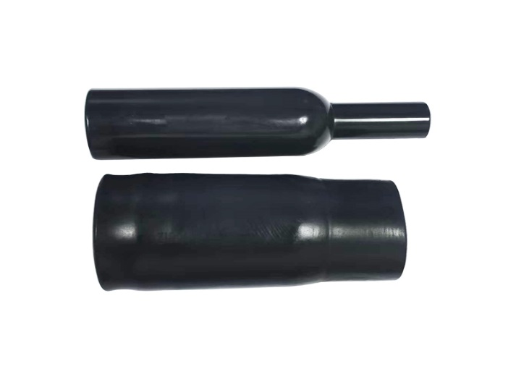

直型无唇口模缩套Nonlipped Straight Boots

YF-Z021~921 Series

功能和优点Features and benefits
- 机械保护和应力消除Mechanical protection and strain relief.
- 不含唇口Does not have a lip.
- 直接安装在连接器附件螺纹上be installed directly onto the connector accessory thread.

订购信息Ordering Information
- 标准颜色：黑色 Standard color: Black.
- 请根据产品编号系统指定产品名称、尺寸、材料、涂层和所需的任何修改。Please specify the product name, size, material, coating and any modifications required, as per Part Numbering System.
- 内层热熔胶是可选的。如果预涂胶，入口尺寸直径将减少1.5mm左右。Adhesive lining is optional. If added the entry dimension diameter will be reduced by 1.5mm.
- 模缩套采用单独包装。Molded parts are individually packaged.
- 除非另有说明，否则尺寸适用于所有可用材料。Dimensions apply to all available materials unless otherwise stated.
YF-Z021-921 Series supplied / fully recovered.

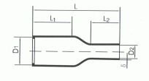

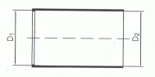

a: Expanded form (supplied) b: Fully recovered form (after heating)
产品编号Part NO. | D1(mm) |  |  | D2(mm) |  |  | L  (mm) | L1  (mm) | L2  (mm) | δ  (mm)
产品编号Part NO. | 收缩前As supplied | 收缩后After recovered | 使用范围Scope of use | 收缩前As supplied | 收缩后After recovered | 使用范围Scope of use
Z021 | 11 | 5.0 | 9~6.6 | 11 | 2.0 | 6.6~2.2 | 40 | 21 | 12 | 1.5
Z121 | 18 | 7.0 | 15~9.4 | 18 | 3.0 | 10~3.2 | 43 | 21 | 14 | 1.5
Z1212 | 18 | 7.0 | 15~9.4 | 18 | 4.0 | 10~4.3 | 50 | 18 | 28 | 1.8
Z221 | 25 | 9.5 | 20~12.6 | 25 | 4.0 | 15~4.3 | 50 | 23 | 16 | 1.6
Z2212 | 25 | 11.0 | 20~14 | 25 | 7.0 | 15~7.6 | 82 | 25 | 56 | 1.8
Z321 | 30 | 13.0 | 25~17.4 | 30 | 6.0 | 18~6.4 | 56 | 25 | 20 | 1.8
Z421 | 34 | 16.8 | 28~21 | 34 | 7.0 | 20~7.5 | 60 | 26 | 20 | 2.0
Z4212 | 34 | 16.8 | 28~21 | 34 | 7.0 | 20~7.5 | 70 | 36 | 20 | 2.0
Z521 | 40 | 20.0 | 33~25 | 40 | 8.4 | 24~9.0 | 68 | 30 | 20 | 2.0
Z5212 | 40 | 20.0 | 33~25 | 40 | 8.4 | 24~9.0 | 85 | 48 | 20 | 2.0
Z621 | 46 | 26.0 | 40~32 | 46 | 9.0 | 27~9.6 | 70 | 30 | 20 | 2.3
Z6212 | 46 | 26.0 | 40~32 | 46 | 9.0 | 27~9.6 | 85 | 45 | 20 | 2.3
Z721 | 60 | 30.0 | 52~37 | 60 | 14.0 | 36~15 | 70 | 30 | 20 | 2.6
Z821 | 75 | 40.0 | 62~48 | 75 | 18.0 | 45~19.5 | 70 | 30 | 20 | 2.6

可根据要求提供其他尺寸和颜色。
Other sizes and colors are available upon request
对于这些成型形状，可提供多种材料/粘合剂组合。请参考模缩套产品目录。
For these molded shapes a wide range of material / adhesive combinations are available. Please refer to the molded shapes catalogue.

Date of issue: Mar 2024

直型带唇口模缩套Lipped straight boots

YF-ZI021~921 Series

功能和优点Features and benefits
- 机械保护和应力消除Mechanical protection and strain relief.
- 根据需要包括一个或多个唇部。Part includes a lip or lips as required.
- 安装在适当外壳尺寸的圆形适配器上。be installed onto circular adaptors of the appropriate shell size.

订购信息Ordering Information
- 标准颜色：黑色 Standard color: Black.
- 请根据产品编号系统指定产品名称、尺寸、材料、涂层和所需的任何修改。Please specify the product name, size, material, coating and any modifications required, as per Part Numbering System.
- 内层热熔胶是可选的。如果预涂胶，入口尺寸直径将减少1.5mm左右。Adhesive lining is optional. If added the entry dimension diameter will be reduced by 1.5mm.
- 模缩套采用单独包装。Molded parts are individually packaged.
- 除非另有说明，否则尺寸适用于所有可用材料。Dimensions apply to all available materials unless otherwise stated.
YF-ZI021-921 Series supplied / fully recovered.

a: Expanded form (supplied) b: Fully recovered form (after heating)
产品编号  Part NO. | D1(mm) |  |  | D2(mm) |  |  | L  (mm) | L1  (mm) | L2  (mm) | δ  (mm)
产品编号  Part NO. | 收缩前As supplied | 收缩后After recovered | 使用范围Scope of use | 收缩前As supplied | 收缩后After recovered | 使用范围Scope of use
ZI021 | 11 | 5.0 | 9~6.6 | 11 | 2.0 | 6.6~2.2 | 40 | 21 | 12 | 1.5
ZI121 | 18 | 7.0 | 15~9.4 | 18 | 3.0 | 10~3.2 | 43 | 21 | 14 | 1.5
ZI1212 | 18 | 7.0 | 15~9.4 | 18 | 4.0 | 10~4.3 | 50 | 18 | 28 | 1.8
ZI221 | 25 | 9.5 | 20~12.6 | 25 | 4.0 | 15~4.3 | 50 | 23 | 16 | 1.6
ZI2212 | 25 | 11.0 | 20~14 | 25 | 7.0 | 15~7.6 | 82 | 25 | 56 | 1.8
ZI321 | 30 | 13.0 | 25~17.4 | 30 | 6.0 | 18~6.4 | 56 | 25 | 20 | 1.8
ZI421 | 34 | 16.8 | 28~21 | 34 | 7.0 | 20~7.5 | 60 | 26 | 20 | 2.0
ZI4212 | 34 | 16.8 | 28~21 | 34 | 7.0 | 20~7.5 | 70 | 36 | 20 | 2.0
ZI521 | 40 | 20.0 | 33~25 | 40 | 8.4 | 24~9.0 | 68 | 30 | 20 | 2.0
ZI5212 | 40 | 20.0 | 33~25 | 40 | 8.4 | 24~9.0 | 85 | 48 | 20 | 2.0
ZI621 | 46 | 26.0 | 40~32 | 46 | 9.0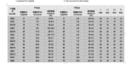 | 27~9.6 | 70 | 30 | 20 | 2.3
ZI6212 | 46 | 26.0 | 40~32 | 46 | 9.0 | 27~9.6 | 85 | 45 | 20 | 2.3
ZI721 | 60 | 30.0 | 52~37 | 60 | 14.0 | 36~15 | 70 | 30 | 20 | 2.6
ZI821 | 75 | 40.0 | 62~48 | 75 | 18.0 | 45~19.5 | 70 | 30 | 20 | 2.6

可根据要求提供其他尺寸和颜色。
Other sizes and colors are available upon request
对于这些成型形状，可提供多种材料/粘合剂组合。请参考模缩套产品目录。
For these molded shapes a wide range of material / adhesive combinations are available. Please refer to the molded shapes catalogue.

直角带唇口模缩套90° lipped boots

YF-W029~929 Series
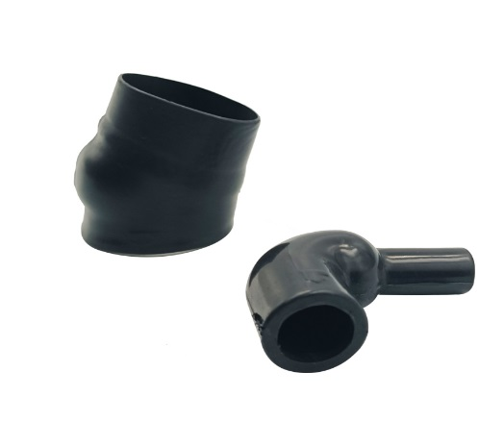
功能和优点Features and benefits
- 机械保护和应力消除Mechanical protection and strain relief.
- 根据需要包括一个或多个唇部。Part includes a lip or lips as required.
- 安装在适当外壳尺寸的圆形适配器上。be installed onto circular adaptors of the appropriate shell size.

订购信息Ordering Information
- 标准颜色：黑色 Standard color: Black.
- 请根据产品编号系统指定产品名称、尺寸、材料、涂层和所需的任何修改。Please specify the product name, size, material, coating and any modifications required, as per Part Numbering System.
- 内层热熔胶是可选的。如果预涂胶，入口尺寸直径将减少1.5mm左右。Adhesive lining is optional. If added the entry dimension diameter will be reduced by 1.5mm.
- 模缩套采用单独包装。Molded parts are individually packaged.
- 除非另有说明，否则尺寸适用于所有可用材料。Dimensions apply to all available materials unless otherwise stated.
YF-W029~929 Series supplied / fully recovered.

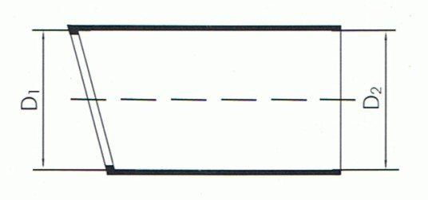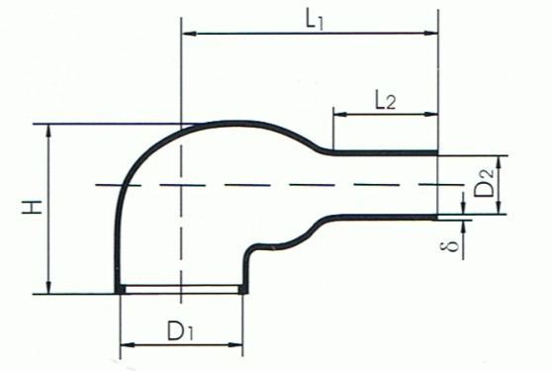

a: Expanded form (supplied) b: Fully recovered form (after heating)

产品编号  Part NO. | D1(mm) |  |  | D2(mm) |  |  | H±10%  (mm) | L1±10%  (mm) | L2±10%  (mm) | δ±20%  (mm)
产品编号  Part NO. | 收缩前As supplied | 收缩后After recovered | 使用范围Scope of use | 收缩前As supplied | 收缩后After recovered | 使用范围Scope of use
W129 | 18 | 7.0 | 15~9.4 | 18 | 3.0 | 10~3.2 | 20.0 | 21 | 10 | 1.5
W229 | 25 | 9.5 | 20~12.6 | 25 | 4.0 | 15~4.3 | 26.0 | 32 | 15 | 1.6
W329 | 30 | 13.0 | 25~17.4 | 30 | 6.0 | 18~6.4 | 28.4 | 34 | 16 | 1.6
W429 | 34 | 16.8 | 28~21.0 | 34 | 7.0 | 20~7.5 | 34.0 | 42 | 18 | 2.0
W529 | 40 | 20.0 | 33~25 | 40 | 8.4 | 24~9.0 | 38.0 | 47 | 20 | 2.0
W629 | 46 | 26.0 | 40~32 | 46 | 9.0 | 27~9.6 | 46.2 | 56 | 20 | 2.3
W729 | 60 | 30.0 | 52~37 | 60 | 14 | 36~15.0 | 54.0 | 62 | 21 | 2.6
W829 | 75 | 40.0 | 62~48 | 75 | 18 | 45~19.5 | 64.0 | 79 | 25 | 2.6

可根据要求提供其他尺寸和颜色。
Other sizes and colors are available upon request
对于这些成型形状，可提供多种材料/粘合剂组合。请参考模缩套产品目录。
For these molded shapes a wide range of material / adhesive combinations are available. Please refer to the molded shapes catalogue..

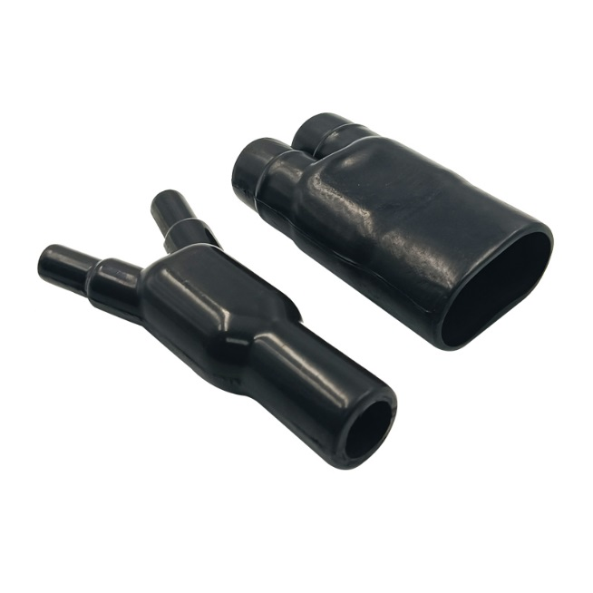

Y型分叉套 Y shape transitions

YF-C138~438 Series

功能和优点Features and benefits
- 机械保护和应力解除Used for mechanical protection and cable strain relief.
- 非常适合需要平衡电缆分支和断路器的电缆线束应用Ideal for cable harness applications where balanced cable branches and breakouts are required.

订购信息Ordering Information
- 标准颜色：黑色 Standard color: Black.
- 请根据产品编号系统指定产品名称、尺寸、材料、涂层和所需的任何修改。Please specify the product name, size, material, coating and any modifications required, as per Part Numbering System.
- 内层热熔胶是可选的。如果预涂胶，入口尺寸直径将减少1.5mm左右。Adhesive lining is optional. If added the entry dimension diameter will be reduced by 1.5mm.
- 模缩套采用单独包装。Molded parts are individually packaged.
- 除非另有说明，否则尺寸适用于所有可用材料。Dimensions apply to all available materials unless otherwise stated.
YF-C138~438 Series supplied / fully recovered.

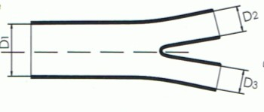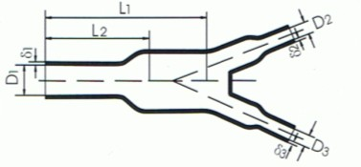

a: Expanded form (supplied) b: Fully recovered form (after heating)

产品编号Part NO. | D1(mm) |  | D2、D3、D4(mm) |  | L1(mm) | L2(mm) | δ1(mm) | δ2、δ3  (mm)
产品编号Part NO. | 收缩前As supplied | 收缩后After recovered | 收缩前As supplied | 收缩后After recovered
C138 | 13.5 | 6.0 | 6.6 | 3.3 | 24.0 | 15.5 | 1.52 | 1.02
C238 | 27.0 | 12.4 | 13.2 | 6.1 | 53.3 | 33.0 | 2.54 | 1.52
C338 | 39.0 | 18.0 | 27.0 | 12.4 | 79.0 | 56.0 | 3.05 | 2.54
C438 | 56.0 | 26.0 | 27.0 | 12.7 | 112.0 | 71.0 | 3.60 | 2.54

可根据要求提供其他尺寸和颜色。
Other sizes and colors are available upon request
对于这些成型形状，可提供多种材料/粘合剂组合。请参考模缩套产品目录。
For these molded shapes a wide range of material / adhesive combinations are available. Please refer to the molded shapes catalogue..

30°Y型分叉套 30° Y shape transitions

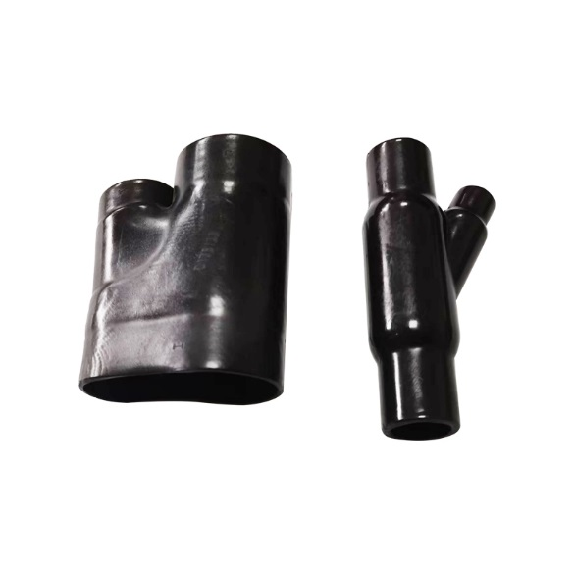
YF-C138~438/30 Series

功能和优点Features and benefits
- 机械保护和应力解除Used for mechanical protection and cable strain relief.
- 非常适合需要平衡电缆分支和断路器的电缆线束应用Ideal for cable harness applications where balanced cable branches and breakouts are required.

订购信息Ordering Information
- 标准颜色：黑色 Standard color: Black.
- 请根据产品编号系统指定产品名称、尺寸、材料、涂层和所需的任何修改。Please specify the product name, size, material, coating and any modifications required, as per Part Numbering System.
- 内层热熔胶是可选的。如果预涂胶，入口尺寸直径将减少1.5mm左右。Adhesive lining is optional. If added the entry dimension diameter will be reduced by 1.5mm.
- 模缩套采用单独包装。Molded parts are individually packaged.
- 除非另有说明，否则尺寸适用于所有可用材料。Dimensions apply to all available materials unless otherwise stated.

YF-C138~438/30 Series supplied / fully recovered.

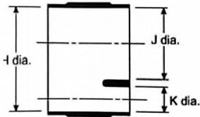
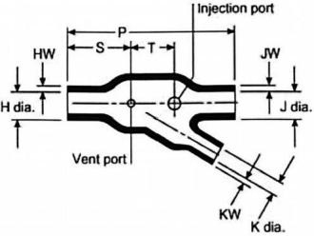
a: Expanded form (supplied) b: Fully recovered form (after heating)
产品编号Part NO. | T | J | K |  | P±10% | S±10% | T±10% | HW/JW±20% | KW±20%
产品编号Part NO. | 收缩前As supplied | 收缩后After recovered | 收缩前As supplied | 收缩后After recovered
C138/30 | 30.5 | 15.7 | 20.3 | 10.7 | 82.6 | 31.8 | 21.1 | 2.54 | 1.78
C238/30 | 35.6 | 18.3 | 15.2 | 8.6 | 63.5 | 19.1 | 22.4 | 2.54 | 1.52
C338/30 | 35.6 | 18.8 | 10.2 | 5.3 | 61.0 | 19.1 | 21.3 | 2.79 | 1.52

可根据要求提供其他尺寸和颜色。
Other sizes and colors are available upon request
对于这些成型形状，可提供多种材料/粘合剂组合。请参考模缩套产品目录。
For these molded shapes a wide range of material / adhesive combinations are available. Please refer to the molded shapes catalogue..

45° Y型分叉套 45° Y shape transitions

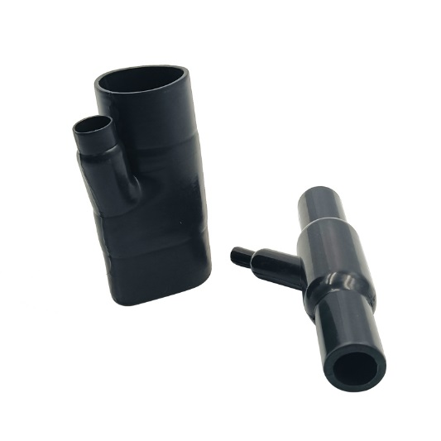
YF-C138~438/45 Series

功能和优点Features and benefits
- 机械保护和应力解除Used for mechanical protection and cable strain relief.
- 非常适合需要平衡电缆分支和断路器的电缆线束应用Ideal for cable harness applications where balanced cable branches and breakouts are required.

订购信息Ordering Information
- 标准颜色：黑色 Standard color: Black.
- 请根据产品编号系统指定产品名称、尺寸、材料、涂层和所需的任何修改。Please specify the product name, size, material, coating and any modifications required, as per Part Numbering System.
- 内层热熔胶是可选的。如果预涂胶，入口尺寸直径将减少1.5mm左右。Adhesive lining is optional. If added the entry dimension diameter will be reduced by 1.5mm.
- 模缩套采用单独包装。Molded parts are individually packaged.
- 除非另有说明，否则尺寸适用于所有可用材料。Dimensions apply to all available materials unless otherwise stated.

YF-C138~438/45 Series supplied / fully recovered.

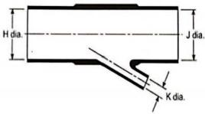
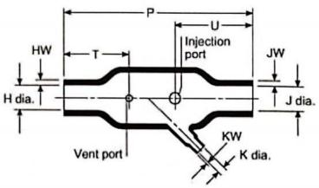
a: Expanded form (supplied) b: Fully recovered form (after heating)
产品编号  Part NO. | T | J | K |  | P±10% | S±10% | T±10% | HW/JW±20% | KW±20%
产品编号  Part NO. | 收缩前As supplied | 收缩后After recovered | 收缩前As supplied | 收缩后After recovered
C138/45 | 13.2 | 6.9 | 6.6 | 3.6 | 49.3 | 19.6 | 19.6 | 1.52 | 1.02
C238/45 | 26.9 | 12.7 | 6.6 | 3.6 | 92.5 | 31.8 | 39.6 | 2.54 | 1.02
C238/45 | 26.9 | 13.7 | 13.2 | 6.1 | 144.8 | 50.8 | 50.8 | 2.54 | 1.52
C338/45 | 55.6 | 26.9 | 13.2 | 6.9 | 184.9 | 63.5 | 63.5 | 4.57 | 1.52
C338/45 | 55.6 | 26.9 | 26.9 | 13.7 | 203.5 | 66.0 | 66.0 | 4.57 | 2.54

可根据要求提供其他尺寸和颜色。
Other sizes and colors are available upon request
对于这些成型形状，可提供多种材料/粘合剂组合。请参考模缩套产品目录。
For these molded shapes a wide range of material / adhesive combinations are available. Please refer to the molded shapes catalogue..

T型分叉套 T shape transitions

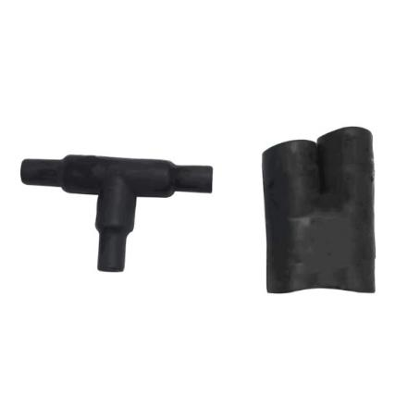
YF-T1494~4494 Series

功能和优点Features and benefits
- 机械保护和应力解除Used for mechanical protection and cable strain relief.
- 非常适合需要平衡电缆分支和断路器的电缆线束应用Ideal for cable harness applications where balanced cable branches and breakouts are required.

订购信息Ordering Information
- 标准颜色：黑色 Standard color: Black.
- 请根据产品编号系统指定产品名称、尺寸、材料、涂层和所需的任何修改。Please specify the product name, size, material, coating and any modifications required, as per Part Numbering System.
- 内层热熔胶是可选的。如果预涂胶，入口尺寸直径将减少1.5mm左右。Adhesive lining is optional. If added the entry dimension diameter will be reduced by 1.5mm.
- 模缩套采用单独包装。Molded parts are individually packaged.
- 除非另有说明，否则尺寸适用于所有可用材料。Dimensions apply to all available materials unless otherwise stated.

YF-T1494~4494 Series supplied / fully recovered.

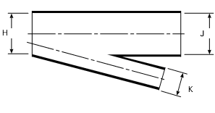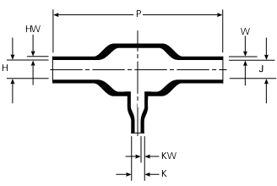

a: Expanded form (supplied) b: Fully recovered form (after heating)

产品编号  Part NO. | 收缩前As Supplied |  | 收缩后After Recovery |  | P  ±10% | T  ±10% | U  ±10% | HW/JW  ±20% | KW  ±20%
产品编号  Part NO. | H, J | K | H, J | K
T1494 | 13.2 | 6.6 | 6.9 | 3.6 | 49.3 | 19.6 | 19.6 | 1.52 | 1.02
T2494 | 26.9 | 6.6 | 12.7 | 3.6 | 92.5 | 31.8 | 39.6 | 2.54 | 1.02
T3494 | 26.9 | 13.2 | 13.7 | 6.1 | 144.8 | 50.8 | 50.8 | 2.54 | 1.52
T4494 | 55.6 | 13.2 | 26.9 | 6.9 | 184.9 | 63.5 | 63.5 | 4.57 | 1.52
可根据要求提供其他尺寸和颜色。
Other sizes and colors are available upon request
对于这些成型形状，可提供多种材料/粘合剂组合。请参考模缩套产品目录。
For these molded shapes a wide range of material / adhesive combinations are available. Please refer to the molded shapes catalogue..

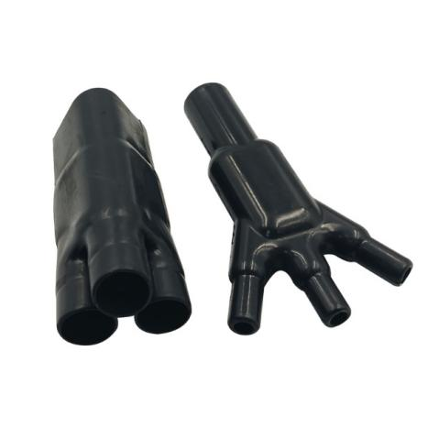
1:3分叉套 1 to 3 Bulbous transitions

YF-C148~548 Series

功能和优点Features and benefits
- 机械保护和应力解除Mechanical protection and strain relief.
- 非常适合需要多个电缆分支的线束应用。Ideal for cable harness applications where multiple cable branches are required.

订购信息Ordering Information
- 标准颜色：黑色 Standard color: Black.
- 请根据产品编号系统指定产品名称、尺寸、材料、涂层和所需的任何修改。Please specify the product name, size, material, coating and any modifications required, as per Part Numbering System.
- 内层热熔胶是可选的。如果预涂胶，入口尺寸直径将减少1.5mm左右。Adhesive lining is optional. If added the entry dimension diameter will be reduced by 1.5mm.
- 模缩套采用单独包装。Molded parts are individually packaged.
- 除非另有说明，否则尺寸适用于所有可用材料。Dimensions apply to all available materials unless otherwise stated.

YF-C148~548 Series supplied / fully recovered.
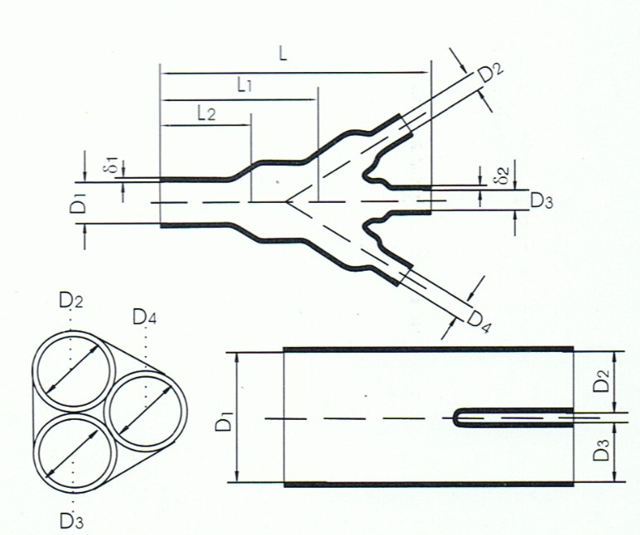

产品编号  Part NO. | D1 |  | D2.D3.D4 |  | L±10% | L1±10% | L2±10% | δ1±20% | δ2±20%
产品编号  Part NO. | 收缩前As supplied | 收缩后After recovered | 收缩前As supplied | 收缩后After recovered
C148 | 14.0 | 6.6 | 6.6 | 3.6 | 46.0 | 31.0 | 15.7 | 1.52 | 1.02
C248 | 27.0 | 13.2 | 13.2 | 6.9 | 94.0 | 57.0 | 33.0 | 2.54 | 1.52
C348 | 39.0 | 18.8 | 19.3 | 9.7 | 135.0 | 89.0 | 46.0 | 3.05 | 1.78
C448 | 56.0 | 25.4 | 27.0 | 12.4 | 192.0 | 122.0 | 71.0 | 4.0 | 2.8
C548 | 92.0 | 54.0 | 46.0 | 27.0 | 390.0 | 254.0 | 127.0 | 6.0 | 3.0
可根据要求提供其他尺寸和颜色。
Other sizes and colors are available upon request
对于这些成型形状，可提供多种材料/粘合剂组合。请参考模缩套产品目录。
For these molded shapes a wide range of material / adhesive combinations are available. Please refer to the molded shapes catalogue..

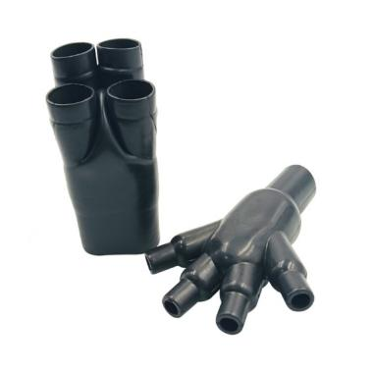
1:4分叉套 1 to 4 Bulbous transitions

YF-C158~658 Series

功能和优点Features and benefits
- 机械保护和应力解除Mechanical protection and strain relief.
- 非常适合需要多个电缆分支的线束应用。Ideal for cable harness applications where multiple cable branches are required.

订购信息Ordering Information
- 标准颜色：黑色 Standard color: Black.
- 请根据产品编号系统指定产品名称、尺寸、材料、涂层和所需的任何修改。Please specify the product name, size, material, coating and any modifications required, as per Part Numbering System.
- 内层热熔胶是可选的。如果预涂胶，入口尺寸直径将减少1.5mm左右。Adhesive lining is optional. If added the entry dimension diameter will be reduced by 1.5mm.
- 模缩套采用单独包装。Molded parts are individually packaged.
- 除非另有说明，否则尺寸适用于所有可用材料。Dimensions apply to all available materials unless otherwise stated.

YF-C158~658 Series supplied / fully recovered

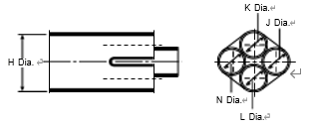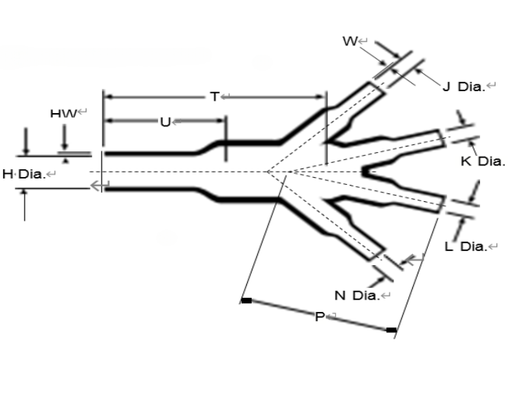
a: Expanded form (supplied) b: Fully recovered form (after heating)

产品编号  Part NO | 收缩前As Supplied |  | 收缩后After Recovery
产品编号  Part NO | H | J, K, L, N | H | J, K, L, N | P  ±10% | T  ±10% | U  ±10% | HW  ±20% | W  ±20%
C158 | 13.2 | 6.6 | 6.9 | 3.4 | 24.1 | 43.9 | 18.0 | 1.52 | 1.02
C258 | 19.3 | 9.4 | 9.7 | 5.3 | 35.6 | 43.2 | 23.1 | 1.78 | 1.02
C358 | 19.3 | 13.2 | 9.7 | 6.9 | 49.3 | 50.5 | 25.4 | 1.78 | 1.52
C458 | 26.9 | 13.2 | 13.0 | 6.9 | 49.3 | 65.8 | 33.5 | 2.54 | 1.52
C558 | 38.6 | 19.3 | 18.5 | 9.7 | 71.9 | 95.3 | 46.5 | 3.05 | 1.78
C658 | 55.6 | 26.9 | 26.7 | 13.0 | 101.6 | 135.1 | 65.5 | 4.57 | 2.54
可根据要求提供其他尺寸和颜色。
Other sizes and colors are available upon request
对于这些成型形状，可提供多种材料/粘合剂组合。请参考模缩套产品目录。
For these molded shapes a wide range of material / adhesive combinations are available. Please refer to the molded shapes catalogue.

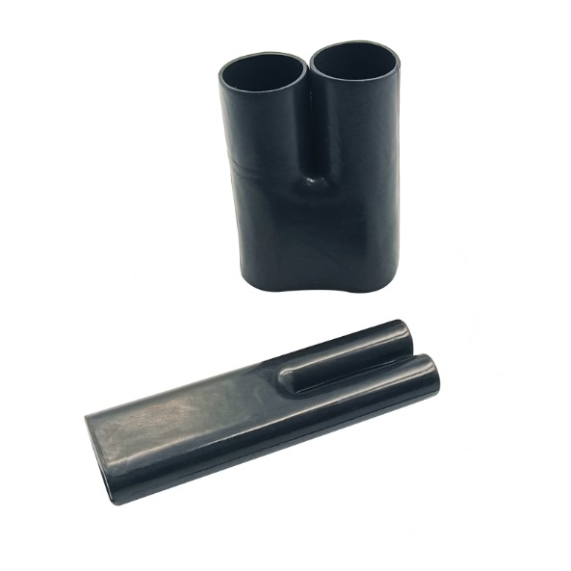
1:2电缆多支分叉套 Cable fork 1 to 2 breakouts

YF-H138~438 Series

功能和优点Features and benefits
- 用于绝缘和密封电缆裆部或导管系统的电缆分接。Cable breakout boots for insulating and sealing cable crotch or conduit system.
- 线束过渡点处的电缆应力消除和机械保护。Cable strain relief and mechanical protection at harness transition points.
- 优异的耐磨性和耐候性。Excellent resistance to abrasion and weathering.

订购信息Ordering Information
- 标准颜色：黑色 Standard color: Black.
- 请根据产品编号系统指定产品名称、尺寸、材料、涂层和所需的任何修改。Please specify the product name, size, material, coating and any modifications required, as per Part Numbering System.
- 内层热熔胶是可选的。如果预涂胶，入口尺寸直径将减少1.5mm左右。Adhesive lining is optional. If added the entry dimension diameter will be reduced by 1.5mm.
- 模缩套采用单独包装。Molded parts are individually packaged.
- 除非另有说明，否则尺寸适用于所有可用材料。Dimensions apply to all available materials unless otherwise stated.

YF-H138~438 Series supplied / fully recovered
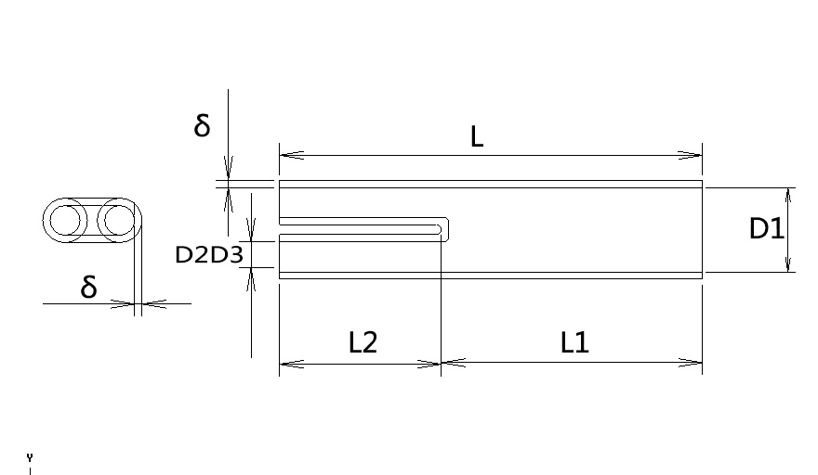

产品编号Part NO | D1(mm) |  | D2D3(mm) |  | L(mm) | 收缩后After Recovery
产品编号Part NO | 收缩前As Supplied | 收缩后After Recovery | 收缩前As Supplied | 收缩后After Recovery | 收缩后After Recovery | L1±10%(mm) | L2±10% (mm) | &±20% (mm)
H138 | 14.0 | 6.6 | 8.0 | 3.6 | 60.0 | 35.0 | 25.0 | 1.2
H238 | 27.0 | 11.0 | 15.0 | 6.0 | 70.00 | 40.0 | 30.0 | 1.8
H338 | 30.0 | 14.00 | 20.0 | 10.0 | 90.00 | 50.0 | 40.0 | 2.1

可根据要求提供其他尺寸和颜色。
Other sizes and colors are available upon request
对于这些成型形状，可提供多种材料/粘合剂组合。请参考模缩套产品目录。
For these molded shapes a wide range of material / adhesive combinations are available. Please refer to the molded shapes catalogue.

1:3电缆多支分叉套 Cable fork 1 to 3 breakouts

YF-E148~448 Series

功能和优点Features and benefits
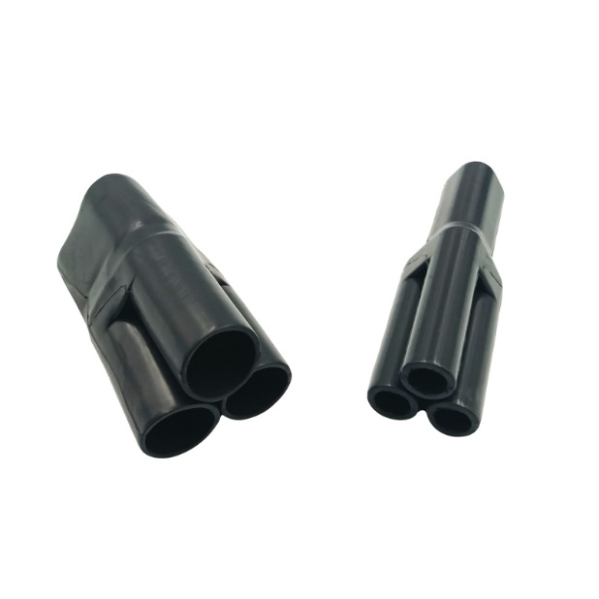
- 用于绝缘和密封电缆裆部或导管系统的电缆分接。Cable breakout boots for insulating and sealing cable crotch or conduit system.
- 线束过渡点处的电缆应力消除和机械保护。Cable strain relief and mechanical protection at harness transition points.
- 优异的耐磨性和耐候性。Excellent resistance to abrasion and weathering.

订购信息Ordering Information
- 标准颜色：黑色 Standard color: Black.
- 请根据产品编号系统指定产品名称、尺寸、材料、涂层和所需的任何修改。Please specify the product name, size, material, coating and any modifications required, as per Part Numbering System.
- 内层热熔胶是可选的。如果预涂胶，入口尺寸直径将减少1.5mm左右。Adhesive lining is optional. If added the entry dimension diameter will be reduced by 1.5mm.
- 模缩套采用单独包装。Molded parts are individually packaged.
- 除非另有说明，否则尺寸适用于所有可用材料。Dimensions apply to all available materials unless otherwise stated.

YF-E148~448 Series supplied / fully recovered

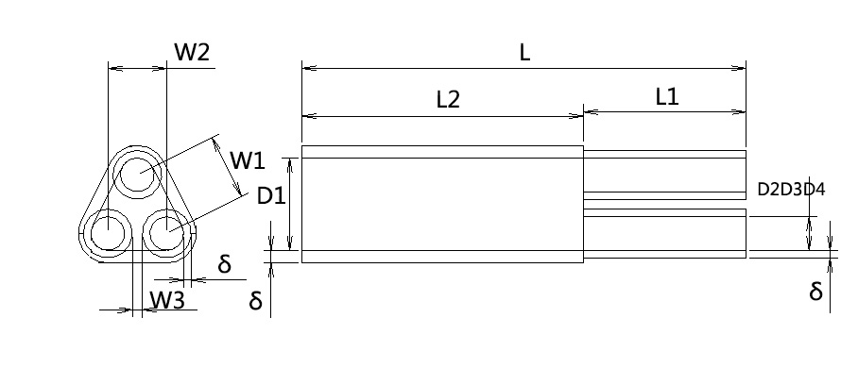

产品编号Part NO | D1(mm) |  | D2D3D4(mm) |  | L(mm) | 收缩后After Recovery
产品编号Part NO | 收缩前As Supplied | 收缩后After Recovery | 收缩前As Supplied | 收缩后After Recovery | 收缩后After Recovery | L1±10% (mm) | L2±10% (mm) | W1±10% (mm) | W2±10% (mm) | W3±10% (mm) | &±20% (mm)
E148 | 14.0 | 6.6 | 8.0 | 3.6 | 60.0 | 25.0 | 35.0 | 7.6 | 7.6 | 2.0 | 1.2
E248 | 27.0 | 10.0 | 12.0 | 6.0 | 70.0 | 30.0 | 40.0 | 11.1 | 11.1 | 2.0 | 1.8
E348 | 30.0 | 14.0 | 18.0 | 9.0 | 90.0 | 40.0 | 50.0 | 15.0 | 15.0 | 2.0 | 2.1

可根据要求提供其他尺寸和颜色。
Other sizes and colors are available upon request
对于这些成型形状，可提供多种材料/粘合剂组合。请参考模缩套产品目录。
For these molded shapes a wide range of material / adhesive combinations are available. Please refer to the molded shapes catalogue.

1:4电缆多支分叉套 Cable fork 1 to 4 breakouts

YF-X158~458 Series
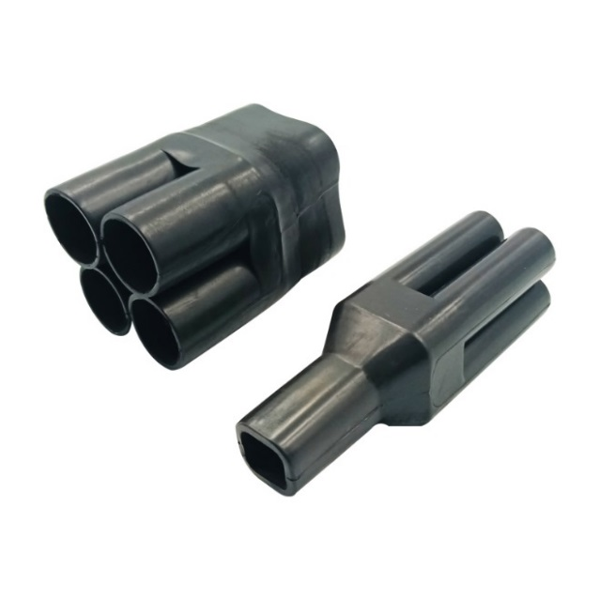
功能和优点Features and benefits
- 用于绝缘和密封电缆裆部或导管系统的电缆分接。Cable breakout boots for insulating and sealing cable crotch or conduit system.
- 线束过渡点处的电缆应力消除和机械保护。Cable strain relief and mechanical protection at harness transition points.
- 优异的耐磨性和耐候性。Excellent resistance to abrasion and weathering.

订购信息Ordering Information
- 标准颜色：黑色 Standard color: Black.
- 请根据产品编号系统指定产品名称、尺寸、材料、涂层和所需的任何修改。Please specify the product name, size, material, coating and any modifications required, as per Part Numbering System.
- 内层热熔胶是可选的。如果预涂胶，入口尺寸直径将减少1.5mm左右。Adhesive lining is optional. If added the entry dimension diameter will be reduced by 1.5mm.
- 模缩套采用单独包装。Molded parts are individually packaged.
- 除非另有说明，否则尺寸适用于所有可用材料。Dimensions apply to all available materials unless otherwise stated.

YF-X158~458 Series supplied / fully recovered

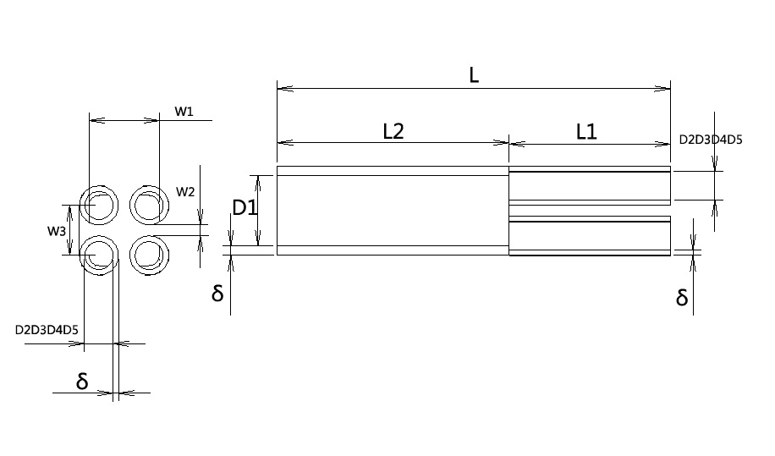

产品编号  Part NO | D1(mm) |  | D2D3D4(mm) |  | L(mm) | 收缩后After Recovered
产品编号  Part NO | 收缩前As Supplied | 收缩后After Recovered | 收缩前As Supplied | 收缩后After Recovered | 收缩后After Recovered | L1±10% (mm) | L2±10% (mm) | W1±10% (mm) | W2±10% (mm) | W3±10% (mm) | &±20% (mm)
X158 | 14.0 | 6.6 | 6.6 | 3.6 | 60.0 | 25.0 | 35.0 | 10.8 | 2.0 | 7.4 | 1.2
X258 | 22.0 | 10.0 | 12.0 | 6.0 | 70.0 | 30.0 | 40.0 | 15.4 | 2.0 | 10.2 | 1.8
X358 | 30.0 | 14.0 | 18.0 | 9.0 | 90.0 | 40.0 | 50.0 | 24.6 | 2.0 | 15.6 | 2.1

可根据要求提供其他尺寸和颜色。
Other sizes and colors are available upon request
对于这些成型形状，可提供多种材料/粘合剂组合。请参考模缩套产品目录。
For these molded shapes a wide range of material / adhesive combinations are available. Please refer to the molded shapes catalogue.

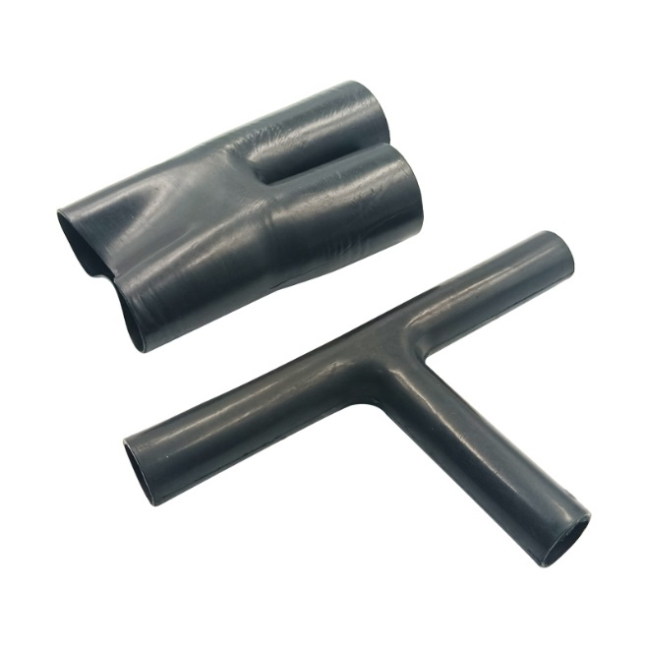

T型柔软分叉套 T shape soft molded sleeve

YF-T1493~4493 Series

功能和优点Features and benefits
- 用于电缆线束分支和过渡。For cable harness breakouts or transitions.
- 应力解除，密封和机械保护。Strain relief, sealing and mechanical protection.
- 能更好顺应电缆线束，节约体积。Better adapt to cables and save more volume.

订购信息Ordering Information
- 标准颜色：黑色 Standard color: Black.
- 请根据产品编号系统指定产品名称、尺寸、材料、涂层和所需的任何修改。Please specify the product name, size, material, coating and any modifications required, as per Part Numbering System.
- 内层热熔胶是可选的。如果预涂胶，入口尺寸直径将减少1.5mm左右。Adhesive lining is optional. If added the entry dimension diameter will be reduced by 1.5mm.
- 模缩套采用单独包装。Molded parts are individually packaged.
- 除非另有说明，否则尺寸适用于所有可用材料。Dimensions apply to all available materials unless otherwise stated.

YF-T1493~4493 Series supplied / fully recovered

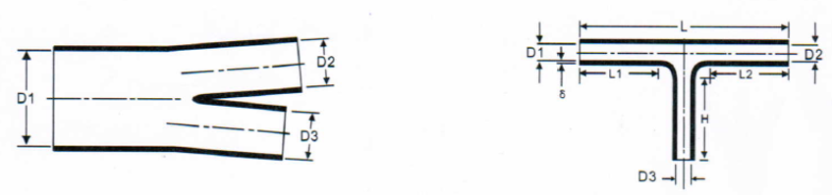

a: Expanded form (supplied) b: Fully recovered form (after heating)

产品编号Part NO. | D1(mm) |  | D2、D3(mm) |  | 收缩后After recovered
产品编号Part NO. | 收缩前As supplied | 收缩后After recovered | 收缩前As supplied | 收缩后After recovered | L±10%  (mm) | L1/L2/H±10%(mm) | &±20% (mm)
T1493 | 19.8 | 6.6 | 13.2 | 6.6 | 80.8 | 25.4 | 1.20
T2493 | 34.3 | 11.4 | 22.9 | 11.4 | 120.4 | 41.1 | 1.27
T3493 | 60.2 | 20.1 | 40.1 | 20.1 | 175.4 | 63.5 | 1.52
T4493 | 83.3 | 33.3 | 54.9 | 33.3 | 242.3 | 88.9 | 1.78

可根据要求提供其他尺寸和颜色。
Other sizes and colors are available upon request
对于这些成型形状，可提供多种材料/粘合剂组合。请参考模缩套产品目录。
For these molded shapes a wide range of material / adhesive combinations are available. Please refer to the molded shapes catalogue.

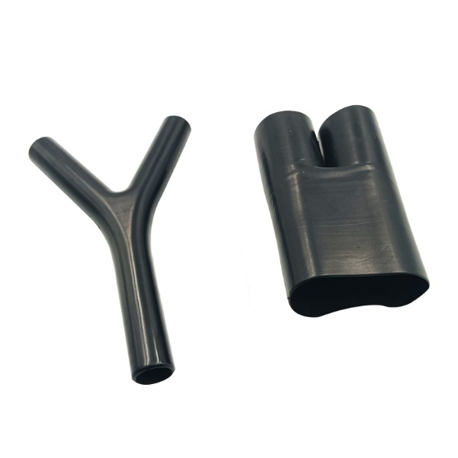

Y型柔软分叉套 Y shape soft molded sleeve

YF-C138~438 Series

功能和优点Features and benefits
- 用于电缆线束分支和过渡。For cable harness breakouts or transitions.
- 应力解除，密封和机械保护。Strain relief, sealing and mechanical protection.
- 能更好顺应电缆线束，节约体积。Better adapt to cables and save more volume.

订购信息Ordering Information
- 标准颜色：黑色 Standard color: Black.
- 请根据产品编号系统指定产品名称、尺寸、材料、涂层和所需的任何修改。Please specify the product name, size, material, coating and any modifications required, as per Part Numbering System.
- 内层热熔胶是可选的。如果预涂胶，入口尺寸直径将减少1.5mm左右。Adhesive lining is optional. If added the entry dimension diameter will be reduced by 1.5mm.
- 模缩套采用单独包装。Molded parts are individually packaged.
- 除非另有说明，否则尺寸适用于所有可用材料。Dimensions apply to all available materials unless otherwise stated.
YF- C138~438 Series supplied / fully recovered

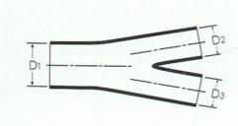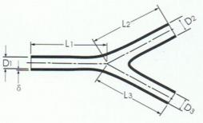

a: Expanded form (supplied) b: Fully recovered form (after heating)

产品编号Part NO. | D1(mm) |  | D2/D3(mm) |  | After recovered
产品编号Part NO. | 收缩前As supplied | 收缩后After recovered | 收缩前As supplied | 收缩后After recovered | L1/L2/L3±10%(mm) | &±20% (mm)
C138 | 19.8 | 6.6 | 13.2 | 6.6 | 40.6 | 1.0
C238 | 34.3 | 11.4 | 22.9 | 11.4 | 63.0 | 1.3
C338 | 60.2 | 20.1 | 40.1 | 20.1 | 94.7 | 1.5
C438 | 83.3 | 33.3 | 54.9 | 33.3 | 133.9 | 1.8

可根据要求提供其他尺寸和颜色。
Other sizes and colors are available upon request
对于这些成型形状，可提供多种材料/粘合剂组合。请参考模缩套产品目录。
For these molded shapes a wide range of material / adhesive combinations are available. Please refer to the molded shapes catalogue.

1:3柔软分叉套1 to 3 soft molded sleeve

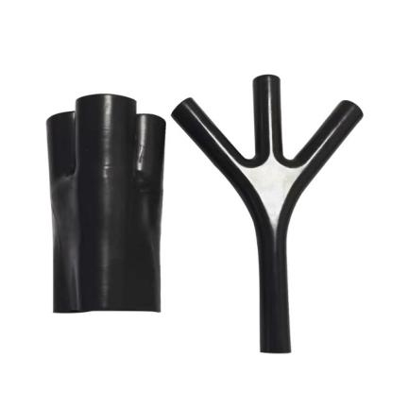
YF-T1433~4433 Series

功能和优点Features and benefits
- 用于电缆线束分支和过渡。For cable harness breakouts or transitions.
- 应力解除，密封和机械保护。Strain relief, sealing and mechanical protection.
- 能更好顺应电缆线束，节约体积。Better adapt to cables and save more volume.

订购信息Ordering Information
- 标准颜色：黑色 Standard color: Black.
- 请根据产品编号系统指定产品名称、尺寸、材料、涂层和所需的任何修改。Please specify the product name, size, material, coating and any modifications required, as per Part Numbering System.
- 内层热熔胶是可选的。如果预涂胶，入口尺寸直径将减少1.5mm左右。Adhesive lining is optional. If added the entry dimension diameter will be reduced by 1.5mm.
- 模缩套采用单独包装。Molded parts are individually packaged.
- 除非另有说明，否则尺寸适用于所有可用材料。Dimensions apply to all available materials unless otherwise stated.

YF-T1433~4433 Series supplied / fully recovered

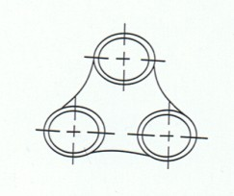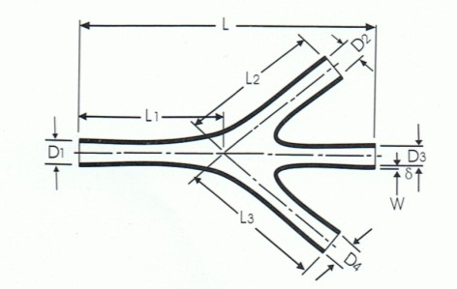

a: Expanded form (supplied) b: Fully recovered form (after heating)

产品编号Part NO. | D1(mm) |  | D2/D3/D4(mm) |  | 收缩后After recovered
产品编号Part NO. | 收缩前As supplied | 收缩后After recovered | 收缩前As supplied | 收缩后After recovered | L±10%  (mm) | L1/L2/L3±10%(mm) | &±20% (mm)
T1433 | 19.8 | 6.6 | 13.2 | 6.6 | 85.9 | 42.9 | 1.0
T2433 | 34.3 | 11.4 | 20.6 | 11.4 | 135.6 | 67.8 | 1.3
T3433 | 60.2 | 20.1 | 36.1 | 20.1 | 207.3 | 103.6 | 1.5
T4433 | 99.8 | 33.3 | 54.9 | 33.3 | 294.6 | 147.3 | 1.8

可根据要求提供其他尺寸和颜色。
Other sizes and colors are available upon request
对于这些成型形状，可提供多种材料/粘合剂组合。请参考模缩套产品目录。
For these molded shapes a wide range of material / adhesive combinations are available. Please refer to the molded shapes catalogue.

定位衬套 Locating Bushes

YF-ZW021~521

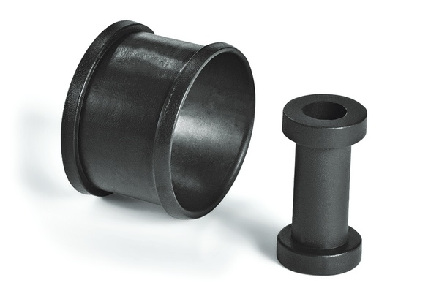
功能和优点Features and benefits
- 为穿过散装封头或外壳入口点的电缆提供定位、缓冲、填隙和保护.Provides location, cushioning, shimming and protection on cable runs through bulk head or enclosure entry points.
- 多种材料和热熔胶可供选择。Available in a range of materials and adhesives for most applications.
- 设计可用于航空发动机领域。Designed for use on aerospace engine applications.

订购信息Ordering Information
- 标准颜色：黑色 Standard color: Black.
- 请根据产品编号系统指定产品名称、尺寸、材料、涂层和所需的任何修改。Please specify the product name, size, material, coating and any modifications required, as per Part Numbering System.
- 内层热熔胶是可选的。如果预涂胶，入口尺寸直径将减少1.5mm左右。Adhesive lining is optional. If added the entry dimension diameter will be reduced by 1.5mm.
- 模缩套采用单独包装。Molded parts are individually packaged.
- 除非另有说明，否则尺寸适用于所有可用材料。Dimensions apply to all available materials unless otherwise stated.
YF-ZW021~521 Series supplied / fully recovered.

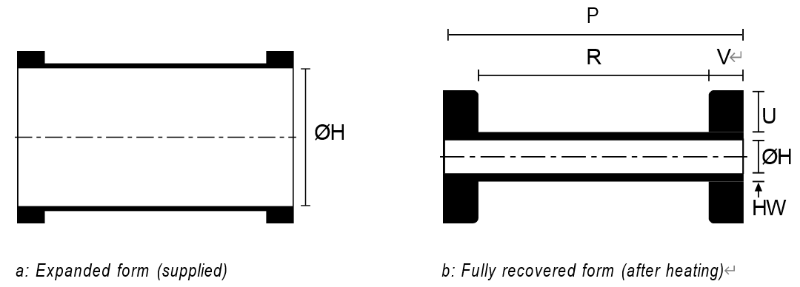

产品编号Part NO. | ØH  min. a(mm) | ØH  max. b(mm) | P ± 10%(mm) | R ± 10 %(mm) | HW ± 20 %(mm) | V ± 10 %(mm) | U ± 20%(mm)
YF-ZW021 | 12.0 | 5.9 | 30.0 | 24.0 | 6.1 | 3.0 | 2.0
YF-ZW121 | 15.0 | 6.4 | 29.0 | 24.0 | 1.5 | 2.5 | 2.0
YF-ZW221 | 16.0 | 7.8 | 32.0 | 24.0 | 6.2 | 4.0 | 2.0
YF-ZW321 | 20.0 | 9.5 | 35.0 | 25.0 | 1.5 | 5.0 | 3.0
YF-ZW421 | 26.0 | 12.7 | 35.0 | 25.0 | 2.0 | 5.0 | 3.0
YF-ZW521 | 30.0 | 18.0 | 35.0 | 25.0 | 2.0 | 5.0 | 3.0

可根据要求提供其他尺寸和颜色。
Other sizes and colors are available upon request
对于这些成型形状，可提供多种材料/粘合剂组合。请参考模缩套产品目录。
For these molded shapes a wide range of material / adhesive combinations are available. Please refer to the molded shapes catalogue.

中核热收缩套管产品
YF-Heat Shrink Tubing

热收缩套管由聚烯烃、弹性体和氟弹性体等材料经造粒、挤出、辐照、扩张制成。在安装过程中加热时，我们的热收缩管几乎可以符合任何形状。它们提供可靠的绝缘、机械保护和应力消除，同时兼顾美观。
Heat shrink tubing is made from materials such as polyolefin, elastomer, and fluoroelastomer through mixing granulation, extrusion, irradiation, and expansion. When heated during installation, our tubing shrink to conform to virtually any shape They provide dependable insulation, mechanical protection, and strain relief, as well as aesthetic appeal.



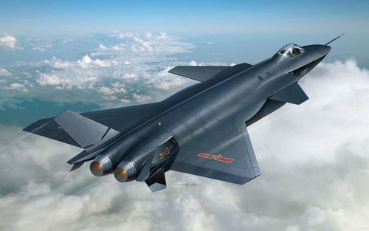

在选择正确的热缩管尺寸时，重要的是要记住80:20规则。热缩管必须收缩至少20%且不超过其完全收缩能力的80%，才能达到正确的效果。在我们的应用概述中，您可以找到适用于每种电缆直径的最佳热缩管。

When selecting the correct heat shrink tubing size, it is important to bear in mind the 80:20 rule. The heat shrink tubing must shrink by at least 20 % and not more than 80 % of its complete shrinkage capacity to achieve the right result. In our overview of applications you will find the best heat shrink tube for every cable diameter.
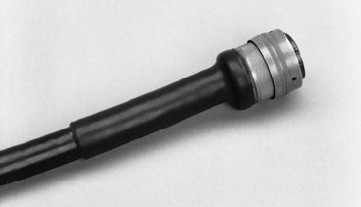
柔软高收缩比含胶双壁热收缩套管
Flexible, High-shrink-ratio, Dual-wall, Adhesive-lined,
Heat-shrinkable polyolefin Tubing

YF-DWT

适用于低压电缆接头和终端的绝缘、密封、防潮和保护。
Suitable for insulation, sealing, moisture-proof, and protection of low-voltage cable joints and terminals.

功能和优点Features and benefits
- 良好的热熔粘结性和高收缩比，提供良好的防潮和耐候密封保护。Good hot-melt adhesive and high expansion ratio to provide good sealing protection from moisture and weathering.
- 无需拆除连接器即可方便地修复大多数损坏的电缆护套。Conveniently repair most damaged cable jackets without removing connectors.
- EVA或PA热熔胶可供选择。EVA hot melt adhesive or PA adhesive are available
- 高收缩率3:1和4:1可实现不规则形状的绝缘和密封。High Shrink ratio 3:1 and 4:1 allows for insulation and sealing of irregular shapes
- 柔软阻燃。Flexible and Flame retardant

材料Material | 交联聚烯烃Polyolefin, cross-linked
收缩比Shrink Ratio | 3:1 & 4:1
使用温度Operating Temperature | -55 °C to +110 °C/135°C
热熔胶软化点Softening Point Adhesive | +80 °C
最低收缩温度Min. Shrink Temperature | +110 °C
纵向收缩率Longitudinal Change After Shrinkage | -10% ~ +10%
介电强度Dielectric Strength | 15 kV/mm
阻燃性Flammability | UL224
耐电压Insulation Grade | 600V

符合标准Approvals
- SAE AMS-DTL-23053/4 class 3
- UL224 110℃/125℃ 600V
- GJB7270-2011，GJB7283-2011

标准颜色Standard color
黑色 Black

性能参数 Property
性 能  Property | 指标要求  Requirement | 测试方法  Test method | 典型值  Typical data
纵向收缩率  Longitudinal shrinkage | -10%~10% | ASTM D2671 | -5%~5%
吸水率(23℃,24小时）  Water absorption rate(23℃,24hrs） | 1.0% max. | ASTM D 570 | ≤0.5%
密封性  Sealing Efficiency | 热熔合处不漏气  No air leakage at the pressed together portion | AMS-DTL-23053/4 | 通过  pass
拉伸强度  Tensile strength | 10.3MPa min. | ASTM D 638 | ≥12MPa
断裂伸长率  Elongation at break | 250％ min | ASTM D 638 | ≥400％
热老化  (158℃,168小时）  Heat aging  (158℃,168hrs) | 外壁无裂纹、无流动、无滴落  No cracks, dripping & flowing of outer wall | ASTM D 2671 | 无裂纹、无流动、无滴落  No cracks, dripping & flowing
热冲击  （250℃, 4小时）  Heat shock  (250℃,4hrs) | 外壁无裂纹、无流动、无滴落  No cracks, dripping & flowing of outer wall | ASTM D 2671 | 无裂纹、无流动、无滴落  No cracks, dripping & flowing
低温柔软性（-55℃,4小时）  Low temperature  flexibility(-55℃,4hrs) | 无裂纹  No crack | ASTM D 2671 | 无裂纹  No crack
绝缘耐压和击穿  Dielectric voltage withstands | 2500V,60sec,不击穿  2500V,60sec, no breakdown | ASTM D 2671 | 不击穿  No breakdown
击穿强度  Dielectric strength | 11.8KV/mm min | ASTM D 2671 | ≥15kv/mm
体积电阻率  Volume resistivity | 10¹² Ω·cm min. | ASTM D 876 | 10¹²Ω·cm
铜腐蚀(121℃,16小时)  Copper corrosion (121℃,16hrs) | 无腐蚀  No Corrosion | ASTM D 2671 | 无腐蚀  No Corrosion
阻燃性  Flammability | All Tubing Flame Test | UL224 | 通过  pass

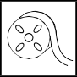
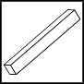

Heat Shrinkable Tubing 3:1&4:1 with adhesive
规格尺寸 Sizes
规格尺寸Size | 收缩前As supplied(mm) | 收缩后After recovered(mm) |  |  | 标准包装Standard packing  (m/根,,m/卷)  (m/pc, m/roll)
规格尺寸Size | 内径Inside diameter(min) | 内径Inside diameter(max.) | 壁厚*  Wall thickness | 胶厚Adhesive thickness(nominal) | 标准包装Standard packing  (m/根,,m/卷)  (m/pc, m/roll)
3:1(英制inch, 公制mm)
1/8(3/1) | 3.0 | 1.0 | 1.00±0.28 | 0.50 | 1.22/200
3/16(4.8/1.6) | 4.8 | 1.6 | 1.00±0.28 | 0.50 | 1.22/100
1/4(6/2) | 6.0 | 2.0 | 1.00±0.28 | 0.50 | 1.22/100
3/8(9/3) | 9.0 | 3.0 | 1.40±0.28 | 0.60 | 1.22/50
1/2(12/4) | 12.0 | 4.0 | 1.78±0.38 | 0.76 | 1.22/25
3/4(18/6) | 18.0 | 6.0 | 2.25±0.55 | 0.76 | 1.22/25
1(24/8) | 24.0 | 8.0 | 2.54±0.55 | 1.02 | 1.22/25
1 1/2(39/13) | 39.0 | 13.0 | 2.54±0.55 | 1.02 | 1.22/25
4:1(公制mm)
4/1 | 4.0 | 1.0 | 1.00±0.28 | 0.50 | 1.22/100
8/2 | 8.0 | 2.0 | 1.00±0.28 | 0.50 | 1.22/50
12/3 | 12.0 | 3.0 | 1.40±0.28 | 0.60 | 1.22/25
16/4 | 16.0 | 4.0 | 1.78±0.38 | 0.76 | 1.22/25
24/6 | 24.0 | 6.0 | 2.25±0.55 | 0.76 | 1.22/25
32/8 | 32.0 | 8.0 | 2.54±0.55 | 1.02 | 1.22/25
52/13 | 52.0 | 13.0 | 2.54±0.55 | 1.02 | 1.22
*壁厚包含胶厚
Wall thickness includes adhesive thickness
可根据要求提供其他尺寸和颜色
Other sizes and colors are available upon request.
最小订单数量（MOQ）可能与包装内容不同。
Minimum Order Quantity (MOQ) may differ from package content.

高性能耐油弹性体热缩管
High performance Diesel Resistant elastomer heat shrink tubing

YF-DR

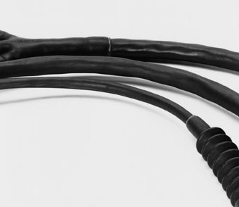
适用于抵抗航空和柴油燃料、液压油和润滑油以及化学溶剂。保护军用车辆中的电缆、线束和连接器。
suitable for resistance to aviation and diesel fuels, hydraulic fluids and lubricating oil, and chemical solvents. To protect cables, wiring harnesses and connectors in military vehicles

功能和优点Features and benefits
- 柔软高性能弹性体热缩管Flexible, high performance elastomeric heat shrink tubing.
- 应用于航空航天、国防、铁路和汽车领域。Used in aerospace, defence, railway and automotive applications.
- 耐柴油、航空燃油和液压油.Resistant to diesel, aviation fuel and hydraulic fluids.
- 提供可靠的保护，防止磨损和机械损坏.Provides a reliable protection against abrasion and mechanical damage.
- 非常适合保护电缆和线束.Very suitable for protecting cables and wire harnesses.
- 耐高温150 °C。For high temperature applications up to 150 °C.

材料Material | 交联聚烯烃弹性体Polyolefin elastomer, cross-linked
收缩比Shrink Ratio | 2:1
使用温度Operating Temperature | -75 °C to +150 °C
最低收缩温度Min. Shrink Temperature | +150 °C
纵向收缩率Longitudinal Change After Shrinkage | -10% ~ +10%
介电强度Dielectric Strength | 16 kV/mm
阻燃性Flammability | self-extinguishing within 1 minute
绝缘等级Insulation Grade | 600V

符合标准Approvals
- SAE AMS-DTL-23053/16
- GJB7270-2011，GJB7274-2011

标准颜色Standard color
黑色Black

性能指标Property
性 能  Property | 指标要求  Requirement | 测试方法  Test method | 典型值  Typical data
纵向收缩率  Longitudinal shrinkage | -10%~10% | ASTM D2671 | -5%~5%
吸水率(23℃,24小时）  Water absorption rate(23℃,24hrs） | 2.0% max. | ASTM D 570 | ≤1.0%
拉伸强度  Tensile strength | 11.7MPa min. | ASTM D 638 | ≥13MPa
断裂伸长率  Elongation at break | 250％ min | ASTM D 638 | ≥400％
老化后拉伸强度  (热老化150℃,168小时）  Tensile strength after aging  (150℃,168hrs) | 10.4Mpa min. | ASTM D 638 | ≥12Mpa
老化后断裂伸长率  (热老化150℃,168小时)  Elongation after ageing  (150℃,168hrs) | 200% min. | ASTM D 638 | ≥300%
热冲击  （200℃, 4小时）  Heat shock  (200℃,4hrs) | 外壁无裂纹、无流动无滴落  No cracks, dripping & flowing of outer wall | ASTM D 2671 | 无裂纹、无流动、无滴落  No cracks, dripping & flowing
低温柔软性（-65℃,4小时）  Low temperature  flexibility(-65℃,4hrs) | 无裂纹  No crack | ASTM D 2671 | 无裂纹  No crack
绝缘耐压和击穿  Dielectric voltage withstand | 2500V,60sec,不击穿  2500V,60sec,no breakdown | ASTM D 2671 | 不击穿  No breakdown
击穿强度  Dielectric strength | 11.9KV/mm min | ASTM D 2671 | ≥16kv/mm
体积电阻率  Volume resistivity | 10⁹Ω·cm min. | ASTM D 876 | 10¹⁰Ω·cm
铜腐蚀(135℃,16小时)  Copper corrosion (135℃,16hrs) | 无腐蚀  No Corrosion | ASTM D 2671 | 无腐蚀  No Corrosion
阻燃性  Flammability | 1分钟内自熄  Self-extinguishing within one minute | ASTM D 2671 | 通过  pass
耐液性（23℃,24hrs)Fluids resistance
拉伸强度  Tensile strength | 10.4MPa min. | ASTM D 638 | ≥12MPa
断裂伸长率  Elongation at break | 200％ min | ASTM D 638 | ≥300％
击穿强度  Dielectric strength | 7.9KV/mm min | ASTM D 2671 | ≥12kv/mm
耐霉菌  Fungus resistance | 不劣于1级  Rating less than 1 | GJB150 | 通过  pass

Heat Shrinkable Tubing 2:1
规格尺寸 Sizes
规格尺寸Size |  | 收缩前As supplied(mm) | 收缩后After recovered(mm) |  | 标准包装(m/卷)  Standard packing  (m/roll)
英制inch | 公制mm | 内径Inside diameter(min) | 内径Inside diameter(max) | 壁厚Wall thickness | 标准包装(m/卷)  Standard packing  (m/roll)
3/32 | Φ2.4 | 2.4 | 1.2 | 0.51±0.08 | 200
1/8 | Φ3.2 | 3.2 | 1.6 | 0.76±0.15 | 100
3/16 | Φ4.8 | 4.8 | 2.4 | 0.84±0.15 | 100
1/4 | Φ6.4 | 6.4 | 3.2 | 0.89±0.15 | 100
3/8 | Φ9.5 | 9.5 | 4.8 | 1.02±0.20 | 50
1/2 | Φ12.7 | 12.7 | 6.4 | 1.22±0.20 | 50
3/4 | Φ19.1 | 19.1 | 9.5 | 1.45±0.28 | 30
1 | Φ25.4 | 25.4 | 12.7 | 1.78±0.28 | 30
1 1/2 | Φ38.1 | 38.1 | 19.1 | 2.41±0.41 | 30
2 | Φ50.8 | 50.8 | 25.4 | 2.79±0.41 | 25

可根据要求提供其他尺寸
Other sizes are available upon request.
最小订单数量（MOQ）可能与包装内容不同。
Minimum Order Quantity (MOQ) may differ from package content.

耐温150℃柔软阻燃PVDF热缩管
150℃ Temperature Resistant, transparent, Flame-Resistant, Flexible, Heat Shrinkable PVDF Tubing

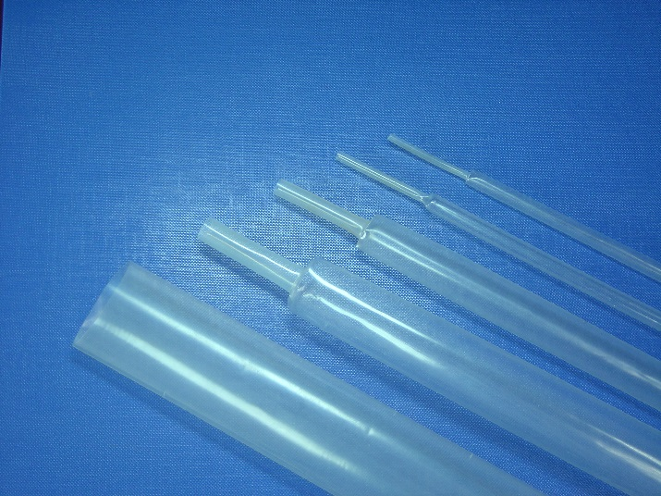
YF-KT150

应用于需要耐高温、耐摩擦的场合，具有优异的的耐化学腐蚀和耐溶剂性能。保护线缆或被覆元器件免受机械损伤或化学腐蚀，用于线缆或元器件的标记保护，连接焊接处的绝缘和应力解除。
Used for where to need high-temperature and abrasion resistance. To prevent wire and cable markers from mechanical and chemical abuse. It reliably protects electronic components while permitting their identification and inspection. Can also be used to provide insulation and strain relief of electrical connections and wire terminations, identification of wires, and packaging of components.

功能和优点Features and benefits
- 透明、柔软PVDF管。Transparent, flexible PVDF tubing.
- 完美保护标识标记。Protect identification marking perfect.
- 高阻燃。Highly flame-resistant.
- 良好的机械和化学耐受性。Good mechanical and chemical resistance.
- 良好的韧性和耐磨性。Good toughness and abration resistance.

材料Material | PVDF, cross-linked
收缩比Shrink Ratio | 2:1
使用温度Operating Temperature | -55 °C to +150 °C
最低收缩温度Min. Shrink Temperature | +150 °C
纵向收缩率Longitudinal Change After Shrinkage | -10%~5%
介电强度Dielectric Strength | 20 kV/mm
阻燃性Flammability | UL224
耐电压Insulation Grade | 600V

符合标准Approvals
- SAE AMS-DTL-23053/18 Class 2
- UL224 150℃ 600V VW-1
- GJB7270-2011，GJB7284-2011

标准颜色Standard color
透明 Transparent

性 能  Property | 指标要求  Requirement | 测试方法  Test method | 典型值  Typical data
纵向收缩率  Longitudinal shrinkage | -10%~5% | ASTM D2671 | -5%~5%
吸水率(23℃,24小时）  Water absorption rate(23℃,24hrs） | 0.5% max. | ASTM D 570 | ≤0.3%
拉伸强度  Tensile strength | 24.5MPa min. | ASTM D 638 | ≥35MPa
断裂伸长率  Elongation at break | 300％ min | ASTM D 638 | ≥400％
老化后断裂伸长率  (225℃,168小时)  Elongation after aging  (225℃,168hrs) | 100% min. | ASTM D 638 | ≥200%
热冲击  （275℃, 4小时）  Heat shock  (275℃,4hrs) | 无裂纹、无流动、无滴落  No cracks, dripping & flowing | ASTM D 2671 | 无裂纹、无流动、无滴落  No cracks, dripping & flowing
低温柔软性（-55℃,4小时）  Low temperature  Flexibility(-55℃,4hrs) | 无裂纹  No crack | ASTM D 2671 | 无裂纹  No crack
绝缘耐压和击穿  Dielectric voltage withstands | 2500V,60sec,不击穿  2500V,60sec, no breakdown | ASTM D 2671 | 不击穿  no breakdown
击穿强度  Dielectric strength | 15.8KV/mm min | ASTM D 2671 | ≥20kv/mm
体积电阻率  Volume resistivity | 10¹¹Ω·cm min. | ASTM D 876 | 10¹²Ω·cm
铜腐蚀(160℃,16小时)  Copper corrosion (160℃,16hrs) | 无腐蚀  No Corrosion | ASTM D 2671 | 无腐蚀  No Corrosion
阻燃性  Flammability | VW-1 | UL224 | 通过  pass
耐液性（23℃,24hrs)Fluids Resistance
拉伸强度  Tensile strength | 24.5MPa min. | ASTM D 638 | ≥30MPa
断裂伸长率  Elongation at break | 250％ min | ASTM D 638 | ≥300％
击穿强度  Dielectric strength | 15.8KV/mm min | ASTM D 2671 | ≥18kv/mm
耐霉菌  Fungus resistance | 不劣于1级  Rating less than 1 | GJB150 | 通过  pass

性能指标Property

Heat Shrinkable Tubing 2:1
规格尺寸 Sizes
规格尺寸(Size) |  | 收缩前As supplied(mm) | 收缩后After recovered(mm) |  | 标准包装(m/根, m/卷)Standard packing  (m/pc, m/roll)
英制(inch) | 公制(mm) | 内径Inside diameter(min.) | 内径Inside diameter(max.) | 壁厚Wall thickness | 标准包装(m/根, m/卷)Standard packing  (m/pc, m/roll)
3/64 | Φ1.2 | 1.2 | 0.6 | 0.25±0.05 | 1.2/200
1/16 | Φ1.6 | 1.6 | 0.8 | 0.25±0.05 | 1.2/200
3/32 | Φ2.4 | 2.4 | 1.2 | 0.25±0.05 | 1.2/200
1/8 | Φ3.2 | 3.2 | 1.6 | 0.25±0.05 | 1.2/200
3/16 | Φ4.8 | 4.8 | 2.4 | 0.25±0.05 | 1.2/100
1/4 | Φ6.4 | 6.4 | 3.2 | 0.30±0.08 | 1.2/100
3/8 | Φ9.5 | 9.5 | 4.8 | 0.30±0.08 | 1.2/100
1/2 | Φ12.7 | 12.7 | 6.4 | 0.30±0.08 | 1.2/100
3/4 | Φ19.1 | 19.1 | 9.5 | 0.43±0.08 | 1.2/50
1 | Φ25.4 | 25.4 | 12.7 | 0.48±0.08 | 1.2/50
3/2 | Φ38.1 | 38.1 | 19.1 | 0.51±0.08 | 1.2/50
2 | Φ50.8 | 50.8 | 25.4 | 0.58±0.08 | 1.2/50

可根据要求提供其他尺寸和颜色。
Other sizes and color are available upon request.
最小订单数量（MOQ）可能与包装内容不同。
Minimum Order Quantity (MOQ) may differ from package content.

耐温200℃柔软氟橡胶热缩管
200℃ High Temperature Resistant Flexible Fluoroelastomer Tubing

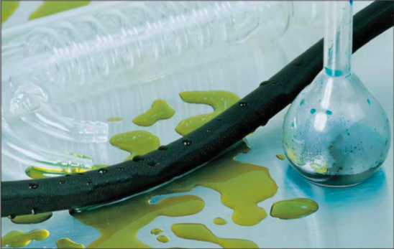
YF-VT200

适用于需要耐高温、耐油、耐化学溶剂的环境，具有优异的耐高温、耐化学腐蚀和耐溶剂性能，防止线束、线缆或被覆元器件在高温或特别苛刻的环境中免受损伤。

Superior impact, abrasion and cut through resistance. Especially used for applications requiring high resistance to corrosive fluids, fuels, lubricants, acids and solvents to prevent wire harnesses, cables and appliances at elevated temperatures.

功能和优点Features and benefits
- 耐高温氟橡胶热缩管。High temperature resistant fluoroelastomeric heat shrink tubing
- 非常好的电气、化学和机械特性。Very good electrical, chemical and mechanical features.
- 耐多种燃料、油和润滑剂。Resistant to many fuels, oils and lubricants
- 低温保持柔软。Flexible even at very low temperatures

符合标准Approvals
材料Material | 交联氟弹性体Fluoroelastomer, cross-linked
收缩比Shrink Ratio | 2:1
使用温度Operating Temperature | -55 °C to +200 °C
最低收缩温度Min. Shrink Temperature | +175 °C
纵向收缩率Longitudinal Change After Shrinkage | -15% ~ +15%
介电强度Dielectric Strength | 12 kV/mm
阻燃性Flammability | 15s内自熄  self-extinguishing within 15s
耐电压Insulation Grade | 600V
- SAE AMS-DTL23053/13
- GJB7270-2011，GJB7283-2011

Standard color
Black

性能指标Property
性 能  Property | 指标要求  Requirement | 测试方法  Test method | 典型值  Typical data
纵向收缩率  Longitudinal shrinkage | -15%~15% | ASTM D2671 | -10%~10%
吸水率(23℃,24小时）  Water absorption rate(23℃,24hrs） | 0.5% max. | ASTM D 570 | ≤0.3%
拉伸强度  Tensile strength | 11.0MPa min. | ASTM D 638 | ≥16MPa
断裂伸长率  Elongation at break | 250％ min | ASTM D 638 | ≥400％
老化后拉伸强度  (热老化250℃,168小时)  Tensile strength after aging  (250℃,168hrs) | 11.0MPa min. | ASTM D 638 | ≥12MPa
老化后断裂伸长率  (热老化250℃,168小时)  Elongation after aging  (250℃,168hrs) | 200% min. | ASTM D 638 | ≥300%
热冲击(300℃,4小时)  Heat shock(300℃,4hrs) | 无裂纹  No crack | ASTM D 2671 | 无裂纹  No crack
低温柔软性（-55℃,4小时）  Low temperature  flexibility(-55℃,4hrs) | 无裂纹  No crack | ASTM D 2671 | 无裂纹  No crack
绝缘耐压和击穿  Dielectric voltage withstands | 2500V,60sec,不击穿  2500V,60sec, no breakdown | ASTM D 2671 | 不击穿  No breakdown
击穿强度  Dielectric strength | 7.9KV/mm min | ASTM D 2671 | ≥12kv/mm
体积电阻率  Volume resistivity | 10⁹ Ω·cm min. | ASTM D 876 | 10⁹Ω· cm
铜腐蚀(175℃,16小时)  Copper corrosion (175℃,16hrs) | 无腐蚀  No Corrosion | ASTM D 2671 | 无腐蚀  No Corrosion
阻燃性  Flammability | 15秒内自熄  Self-extinguishing within 15s | ASTM D 2671 | 通过  pass
耐液性（23℃,24hrs)Fluids Resistance
拉伸强度  Tensile strength | 11.0MPa min. | ASTM D 638 | ≥12MPa
断裂伸长率  Elongation at break | 250％ min | ASTM D 638 | ≥400％
耐霉菌  Fungus resistance | 不劣于1级  Rating less than 1 | GJB150 | 通过  pass

Heat Shrinkable Tubing 2:1

规格尺寸 Sizes
规格尺寸Size |  | 收缩前As supplied(mm) | 收缩后After recovered(mm) |  | 标准包装(m/卷)Standard packing  (m/roll)
英制inch | 公制mm | 内径Inside diameter(min.) | 内径Inside diameter(max.) | 壁厚Wall thickness | 标准包装(m/卷)Standard packing  (m/roll)
3/32 | Φ2.4 | 2.4 | 1.2 | 0.60±0.10 | 200
1/8 | Φ3.2 | 3.2 | 1.6 | 0.76±0.13 | 100
3/16 | Φ4.8 | 4.8 | 2.4 | 0.89±0.18 | 50
1/4 | Φ6.4 | 6.4 | 3.2 | 0.89±0.18 | 50
3/8 | Φ9.5 | 9.5 | 4.8 | 0.89±0.18 | 50
1/2 | Φ12.7 | 12.7 | 6.4 | 0.89±0.18 | 50
3/4 | Φ19.1 | 19.1 | 9.5 | 1.07±0.21 | 30
1 | Φ25.4 | 25.4 | 12.7 | 1.25±0.30 | 30
1 1/2 | Φ38.1 | 38.1 | 19.1 | 1.40±0.38 | 30
2 | Φ50.8 | 50.8 | 25.4 | 1.65±0.43 | 30

可根据要求提供其他尺寸和颜色。
Other sizes and color are available upon request.
最小订单数量（MOQ）可能与包装内容不同。
Minimum Order Quantity (MOQ) may differ from package content.

耐温260℃ PTFE热收缩套管
260℃ High-Temperature Resistant PTFE Heat Shrinkable Tubing

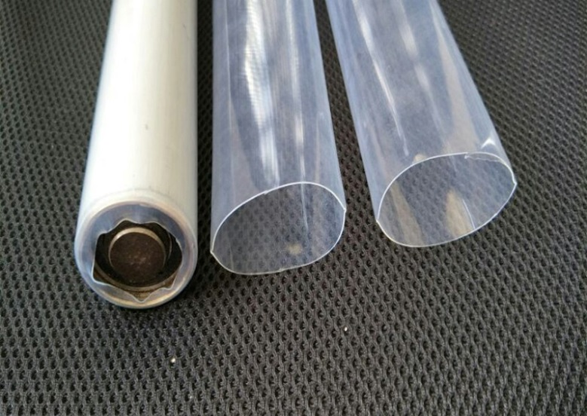
YF-TEFLON

具有耐高温( 260℃ )、耐腐蚀、高绝缘、机械强度佳等特性。其广泛用于电子、计算机、电热、航天、军事、通讯等重要科技工业，如微型变压器等。通常用在液压管道及其管道结合部位以保护管道不受腐蚀。由于它具有非常高的机械强度和极低的摩擦系数，所以是保护受力轴和轴相关产品的理想产品。

High-temperature performance, chemical resistance, high insulation and excellent mechanical properties. Designed to provide insulation and mechanical protection in severe chemical and thermal environments. Widely used in electronic, aerospace, military, and communication fields. Used to cover hydraulic hose and couplings to prevent contamination and corrosion. The high mechanical strength and extremely low coefficient of friction make it good for reducing damage to bearing shafts and similar applications.

功能和优点Features and benefits
- PTFE热缩管。PTFE heat shrink tubing.
- 非常耐高温。Very high temperature resistance.
- 超薄壁透明管Extra thin wall translucent tubing.
- 高耐磨性和良好的耐腐蚀性化学品性High abrasion resistance and good resistance against aggressive .chemicals.
- 优异的阻燃性Excellent flame retardancy.

标准颜色Standard color
透明 Transparent

符合标准Approvals

SAE AMS-DTL-23053/12

GJB7270-2011，GJB7275-2011

材料Material | 聚四氟乙烯Polytetrafluoroethylene (PTFE)
使用温度Operating Temperature | -67 °C to +260 °C
最低收缩温度Min. Shrink Temperature | +350 °C
纵向收缩率Longitudinal Change After Shrinkage | -15% ~ +15%
介电强度Dielectric Strength | 40 kV/mm
阻燃性Flammability | UL224

性能指标Property

性 能  Property | 指标要求  Requirement | 测试方法  Test method | 典型值  Typical data
纵向收缩率  Longitudinal shrinkage | -15%~15% | ASTM D2671 | -10%~10%
拉伸强度  Tensile strength | 17.3MPa min. | ASTM D 638 | ≥25MPa
断裂伸长率  Elongation at break | 200％ min | ASTM D 638 | ≥300％
绝缘耐压和击穿  Dielectric voltage withstands | 2500V,60sec,不击穿  2500V,60sec, no breakdown | ASTM D 2671 | 不击穿  no breakdown
击穿强度  Dielectric strength | 31.5KV/mm min | ASTM D 2671 | ≥40kv/mm
体积电阻率  Volume resistivity | 10¹⁸Ω·cm min. | ASTM D 876 | 10¹⁸Ω·cm
介电常数  Dielectric constant |  |  | 2.1
热冲击(400℃,4小时)  Heat shock(400℃,4hrs) | 无裂纹  No crack | ASTM D 2671 | 无裂纹  No crack
老化后拉伸强度  (350℃, 96小时）  Tensile strength after ageing  (350℃,96hrs) | ≥17.3Mpa min | ASTM D 638 | ≥20Mpa
老化后断裂伸长率  (350℃,96小时)  Elongation after ageing  (350℃,96hrs) | 200% min. | ASTM D 638 | ≥250%
老化后击穿强度(350℃,96小时)  Dielectric strength after ageing  (350℃,96hrs) | 31.5KV/mm min | ASTM D 2671 | ≥35kv/mm
铜腐蚀(250℃,16小时)  Copper corrosion (250℃,16hrs) | 无腐蚀  No Corrosion | ASTM D 2671 | 无腐蚀  No Corrosion
阻燃性  Flammability | VW-1 | UL224 | 通过  pass
摩擦系数  Friction coefficient |  |  | 0.1

Heat Shrinkable Tubing 1.7:1

规格尺寸 Sizes
规格尺寸Size |  | 收缩前As supplied(mm) | 收缩后After recovered(mm) |  | 标准包装(m/根, m/卷)Standard packing  (m/pc, m/roll)
线规AWG | 公制mm | 内径Inside diameter(min.) | 内径Inside diameter(max.) | 壁厚Wall thickness | 标准包装(m/根, m/卷)Standard packing  (m/pc, m/roll)
30 | Φ0.8 | 0.8 | 0.4 | 0.23±0.05 | 1.22/200
28 | Φ0.9 | 0.9 | 0.5 | 0.23±0.05 | 1.22/200
26 | Φ1.1 | 1.1 | 0.6 | 0.25±0.05 | 1.22/200
34 | Φ1.2 | 1.2 | 0.7 | 0.25±0.05 | 1.22/200
22 | Φ1.4 | 1.4 | 0.8 | 0.30±0.08 | 1.22/200
20 | Φ1.5 | 1.5 | 1.0 | 0.30±0.08 | 1.22/200
18 | Φ1.9 | 1.9 | 1.25 | 0.30±0.08 | 1.22/200
16 | Φ2.3 | 2.3 | 1.6 | 0.30±0.08 | 1.22/100
14 | Φ3.0 | 3.0 | 1.85 | 0.30±0.08 | 1.22/100
12 | Φ3.8 | 3.8 | 2.3 | 0.30±0.08 | 1.22/100
10 | Φ4.8 | 4.8 | 2.85 | 0.30±0.08 | 1.22/100
8 | Φ6.1 | 6.1 | 3.6 | 0.38±0.08 | 1.22/100
6 | Φ7.6 | 7.6 | 4.5 | 0.38±0.08 | 1.22/100
4 | Φ9.4 | 9.4 | 5.7 | 0.38±0.08 | 1.22/50
2 | Φ10.9 | 10.9 | 7.1 | 0.38±0.08 | 1.22/50
0 | Φ11.9 | 11.9 | 8.8 | 0.38±0.08 | 1.22/50
可根据要求提供其他尺寸。
Other sizes are available upon request.
最小订单数量（MOQ）可能与包装内容不同。
Minimum Order Quantity (MOQ) may differ from package content.

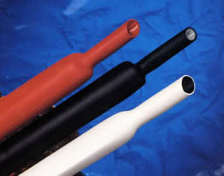
阻燃硅橡胶热缩管
Flame Retardant Silicone Rubber Heat Shrinkable Tubing

YF-GJ200

- 耐高温200℃ 、高阻燃、柔软。广泛用于军事装备中电线线缆、电子部件的连接、绝缘、保护以及连接处的应力解除，尤其适用于-50℃～200℃范围内需要柔软保护的部位。
- High temperature resistance(200℃), high flame resistance, and softness. Used for the connection, insulation, protection, and stress relief of wires, cables, and electronic components in military equipment, especially suitable for areas that require soft protection within the range of -50℃ to 200℃.

功能和优点Features and benefits
- 柔软、高阻燃Flexible and Excellent flammability
- 耐高温200℃。High temperature resistant to 200℃
材料Material | 改性硅橡胶modified silicone rubber
收缩比Shrink Ratio | 1.7:1
使用温度Operating Temperature | -50 °C to +200 °C
最低收缩温度Min. Shrink Temperature | +150 °C
纵向收缩率Longitudinal Change After Shrinkage | -15% ~ +15%
介电强度Dielectric Strength | 20 kV/mm
阻燃性Flammability | UL224
Dielectric constant 50Hz | 3.2

符合标准Approvals
- UL224

标准颜色Standard color
- 红色Red

性 能  Property | 指标要求  Requirement | 测试方法  Test method | 典型值  Typical data
纵向收缩率  Longitudinal shrinkage | -15%~15% | ASTM D2671 | -10%~10%
拉伸强度  Tensile strengthcc | 6.9MPa min. | ASTM D 638 | ≥6.9MPa
断裂伸长率  Elongation at break | 200％ min | ASTM D 638 | 300％
撕裂强度  Tear strength | 15KN/m min.c | ASTM D 638 | 30KN/m
击穿强度  Dielectric strength | 20KV/mm min | ASTM D 2671 | ≥20kv/mm
体积电阻率  Volume resistivity | 10¹²Ω·cm min. | ASTM D 876 | 2×10¹²Ω·cm
介电常数ε,50Hz  Dielectric constant 50Hz | 3.2 | ASTM D150 | 3.2
介质损耗角正切50Hz  Dielectric loss tangent | 0.001 | GB/T1409-2016 | 0.001
阻燃性  Flammability | VW-1 | UL224 | 通过  pass

性能指标 Property

Heat Shrinkable Tubing 1.7:1

规格尺寸 Sizes
规格尺寸Size(mm) | 收缩前As supplied(mm) | 收缩后After recovered(mm) |  | 标准包装(m/卷)Standard packing  (m/roll)
规格尺寸Size(mm) | 内径Inside diameter(min.) | 内径Inside diameter(max.) | 壁厚Wall thickness | 标准包装(m/卷)Standard packing  (m/roll)
Φ1.5 | 1.5 | 0.90 | 0.60 | 50
Φ2.0 | 2.0 | 1.20 | 0.80 | 50
Φ3.0 | 3.0 | 1.80 | 0.80 | 50
Φ4.0 | 4.0 | 2.50 | 1.00 | 50
Φ5.0 | 5.0 | 3.00 | 1.00 | 50
Φ6.0 | 6.0 | 3.60 | 1.00 | 50
Φ8.0 | 8.0 | 5.00 | 1.00 | 50
Φ10.0 | 10.0 | 6.00 | 1.50 | 50
Φ12.0 | 12.0 | 7.20 | 1.50 | 50
Φ15.0 | 15.0 | 9.00 | 1.50 | 50
Φ17.0 | 17.0 | 10.5 | 1.50 | 50
Φ20.0 | 20.0 | 12.5 | 1.50 | 50
Φ25. | 25.0 | 15.0 | 2.00 | 50
Φ30.0 | 30.0 | 18.5 | 2.00 | 50
Φ40.0 | 40.0 | 24.0 | 2.00 | 50
可根据要求提供其他尺寸和颜色。
Other sizesand color are available upon request.
最小订单数量（MOQ）可能与包装内容不同。
Minimum Order Quantity (MOQ) may differ from package content.

